

FACULTY OF COMPUTING SEMESTER II, SESSION 2025/26

SECJ3104 SEC02 APPLICATION DEVELOPMENT

SOFTWARE DATA DESIGN

PROJECT TITLE: ThriftIn UTM

PREPARED BY:
NAME | MATRIC NUMBER
ASILAH BINT MOHD RAZAK
ANGIE WONG SIAW THING
AINA ZAFIRAH BINTI AHMAD MUZAMIR
TAN JIA YING

SUBMISSION DATE:

TABLE OF CONTENT

1.0 INTRODUCTION TO APPLICATION 4
1.1 INTRODUCTION 4
1.2 PROBLEM STATEMENT 4
1.3 THE PROPOSED SYSTEM 4
1.4 TECHNOLOGY AND TOOL USED 4
1.5 FUNCTIONAL REQUIREMENTS 5
2.0 APPLICATION DIAGRAM 6
2.1 ARCHITECTURE DESIGN 6
3.0 USER MANAGEMENT SUBSYSTEM DATA DESIGN 7
3.1. USER REGISTRATION & LOGIN MODULE (ANGIE) 7
3.1.1 DATA DESIGN 7
3.1.1.1 DATA DICTIONARY & DESCRIPTION 7
3.1.2 USER INTERFACE DESIGN 9
3.2 PROFILE AND VERIFICATION MODULE (ANGIE) 13
3.2.1 DATA DESIGN 13
3.2.1.1 DATA DICTIONARY & DESCRIPTION 14
3.2.2 USER INTERFACE DESIGN 17
3.3 ACCESS CONTROL AND AUTHORIZATION MODULE (ANGIE) 25
3.3.1 DATA DESIGN 25
3.3.1.1 DATA DICTIONARY & DESCRIPTION 26
3.3.2 USER INTERFACE DESIGN 30
4.0 PRODUCT AND MARKET SUBSYSTEM DATA DESIGN 38
4.1 PRODUCT LISTING & MANAGEMENT MODULE (AINA ZAFIRAH) 38
4.1.1 DATA DESIGN 38
4.1.1.1 DATA DICTIONARY & DESCRIPTION 38
4.1.2 USER INTERFACE DESIGN 39
4.2 PRODUCT AND MARKET SUBSYSTEM: SEARCH AND RECOMMENDATION MODULE (AINA ZAFIRAH) 41
4.2.1 DATA DESIGN 41
4.2.1.1 DATA DICTIONARY & DESCRIPTION 42
4.2.2 USER INTERFACE DESIGN 44
4.3. PURCHASING AND PAYMENT MODULE (AINA ZAFIRAH) 46
4.3.1 DATA DESIGN 46
4.3.1.1 DATA DICTIONARY & DESCRIPTION 47
4.3.2 USER INTERFACE DESIGN 49
5.0 ANALYTICS AND INSIGHTS SUBSYSTEM DATA DESIGN 53
5.1 USER ACTIVITY DASHBOARD MODULE (ASILAH) 53
5.1.1 DATA DESIGN 53
5.1.1.1 DATA DICTIONARY & DESCRIPTION 53
5.1.2 USER INTERFACE DESIGN 56
5.2 SALES & PERFORMANCE MODULE (ASILAH) 58
5.2.1 DATA DESIGN 58
5.2.1.1 DATA DICTIONARY & DESCRIPTION 58
5.2.2 USER INTERFACE DESIGN 60
5.3 BUYER SPENDING SUMMARY MODULE (ASILAH) 63
5.3.1 DATA DESIGN 63
5.3.1.1 DATA DICTIONARY & DESCRIPTION 63
5.3.2 USER INTERFACE DESIGN 66
6.0 COMMUNICATION AND SUPPORT SUBSYSTEM DATA DESIGN 68
6.1 CHAT & MESSAGING MODULE (JIA YING) 68
6.1.1 DATA DESIGN 68
6.1.1.1 DATA DICTIONARY & DESCRIPTION 68
6.1.2 USER INTERFACE DESIGN 71
6.2 NOTIFICATION & ALERT MODULE (JIA YING) 75
6.2.1 DATA DESIGN 75
6.2.1.1 DATA DICTIONARY & DESCRIPTION 75
6.2.2 USER INTERFACE DESIGN 77
6.3 HELP CENTRE AND FEEDBACK MODULE (JIA YING) 81
6.3.1 DATA DESIGN 81
6.3.1.1 DATA DICTIONARY & DESCRIPTION 82
6.3.2 USER INTERFACE DESIGN 85

INTRODUCTION TO APPLICATION

INTRODUCTION
ThriftIn UTM is a mobile application developed to create a secure and convenient online marketplace exclusively for the Universiti Teknologi Malaysia (UTM) students. It aims to address the challenges faced by students when buying and selling preloved items through informal platforms like WhatsApp or Telegram, where they often lack structure and trust. The app promotes sustainable consumption and supports student entrepreneurship by providing a verified environment for trading used goods such as books, clothes, electronics and room essentials within the campus community.

PROBLEM STATEMENT
Currently, UTM students rely on general messaging groups for selling and buying used items, which often leads to issues such as scams, disorganized listings and deletion of posts by group administrators. There is also no proper verification system to ensure that buyers and sellers are genuine UTM members, causing trust issues. Additionally, students find it difficult to search for specific items or sellers due to the lack of structured organization. Hence, a dedicated and verified digital platform is needed to ensure safety and efficiency and better user experience in student-to-student transactions

THE PROPOSED SYSTEM
The proposed system, ThriftIn UTM, is a cross-platform mobile application designed to centralize the process of buying and selling preloved items within UTM. It includes key subsystems such as User Management for authentication using UTM email, Product and Market for listing and AI-based recommendations, Analytics and Insights for monitoring sales and user activity and Communication and Support for in-app chat and notifications. The system ensures verified users, secure transactions and easy navigation through categorized listing and intelligent search features.

TECHNOLOGY AND TOOL USED
ThriftIn UTM will be developed using React Native for the front end to ensure cross-platform compatibility, and Node.js with Express.js for backend development to handle APIs and business logic. MySQL will be used as the database to manage user, product, and transaction data. For AI-powered product recommendations, FastAPI will serve as a dedicated microservice. Axios will facilitate communication between the frontend and backend. The team will use Figma for UI/UX design, Trello for project management, GitHub for version control, and Expo for testing the mobile application.

FUNCTIONAL REQUIREMENTS

The functional requirements of ThriftIn UTM focus on providing a seamless, secure, and intelligent trading experience for students. The system allows users to register and verify their accounts using official UTM email addresses to ensure that only genuine members of the university community can access the platform. Once verified, users can list their preloved items by adding product details, descriptions, and images through the Product Listing and Management feature. Buyers can easily search and filter items using keywords or categories, while an integrated AI recommendation system suggests relevant products based on user preferences and browsing history. To ensure smooth and safe transactions, the platform supports secure payment options such as e-wallets and bank transfers. Additionally, ThriftIn UTM includes an in-app chat system that enables real-time communication between buyers and sellers, along with instant notifications for messages, updates, and order statuses. For administrators, an analytics dashboard provides valuable insights into user activities, sales trends, and popular product categories, allowing better monitoring and decision-making to enhance the overall platform performance.

APPLICATION DIAGRAM

ARCHITECTURE DESIGN
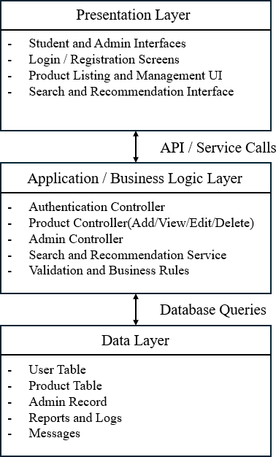

Figure 2.1: Architecture Design of ThriftIn UTM

USER MANAGEMENT SUBSYSTEM DATA DESIGN

3.1. USER REGISTRATION & LOGIN MODULE (ANGIE)

3.1.1 DATA DESIGN

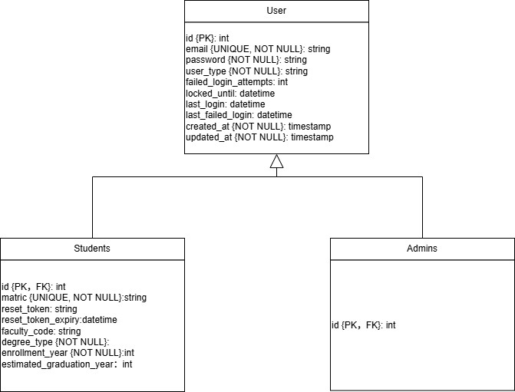

Figure 3.1：Entity Relationship Design (ERD) for User Registration and Login Module

3.1.1.1 DATA DICTIONARY & DESCRIPTION

Entity: User

Attribute name | Data Type | Description
id | int | Primary Key, Auto Increment
email | string | Unique identifier for all users
password | string | Hashed password
user_type | string | Discriminator field
failed_login_attempts | int | Failed login counter
locked_until | datetime | Account lock expiry
last_login | datetime | Last successful login

last_failed_login | datetime | Last failed login
created_at | timestamp | Creation time
updated_at | timestamp | Update time
Table 3.1: Data Dictionary and Description of User Table
Entity: Students

Attribute name | Data Type | Description
id | int | Primary key and foreign key referencing user.id (unique, not null)
user_id | int | Foreign key referencing user.id
matric | string | Unique, student matric number
reset_token | string | Password reset token
reset_token_expiry | datetime | Token expiration
degree_type | string | Degree program
faculty_code | string | Faculty identifier
enrollment_year | int | Year enrolled
estimated_graduation_year | int | Expected graduation year
Table 3.2: Data Dictionary and Description of Students Table
Entity: Admins

Attribute name | Type | Description
id | int | Primary key and foreign key referencing user.id (unique, not null)
(no additional attributes) |  | Uses only inherited fields
Table 3.3: Data Dictionary and Description of Admins Table

3.1.2 USER INTERFACE DESIGN
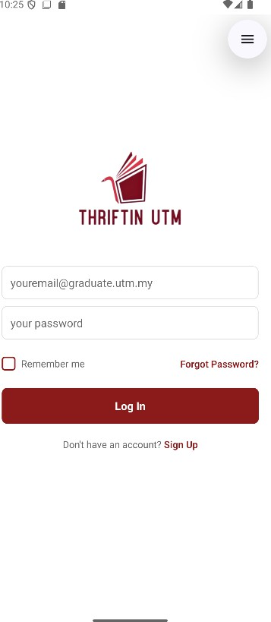
Figure 3.2: User Interface for Login page

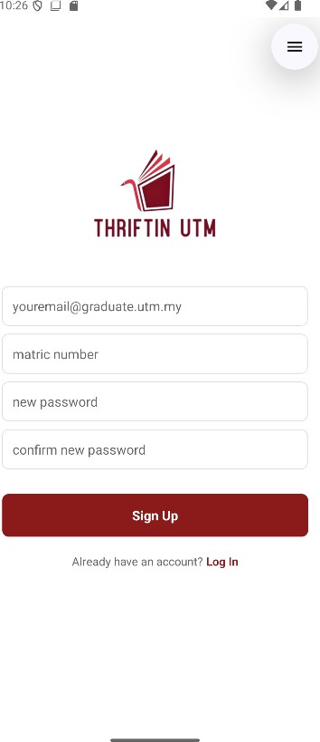
Figure 3.3: User Interface for Register page

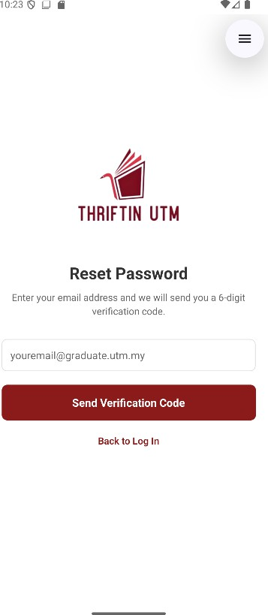
Figure 3.4: User Interface for Request Verification Code page

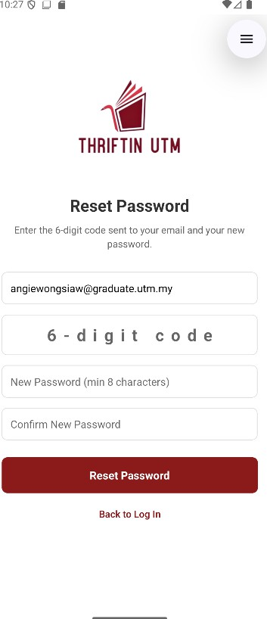
Figure 3.5: User Interface for Reset Password page

3.2 PROFILE AND VERIFICATION MODULE (ANGIE)

3.2.1 DATA DESIGN
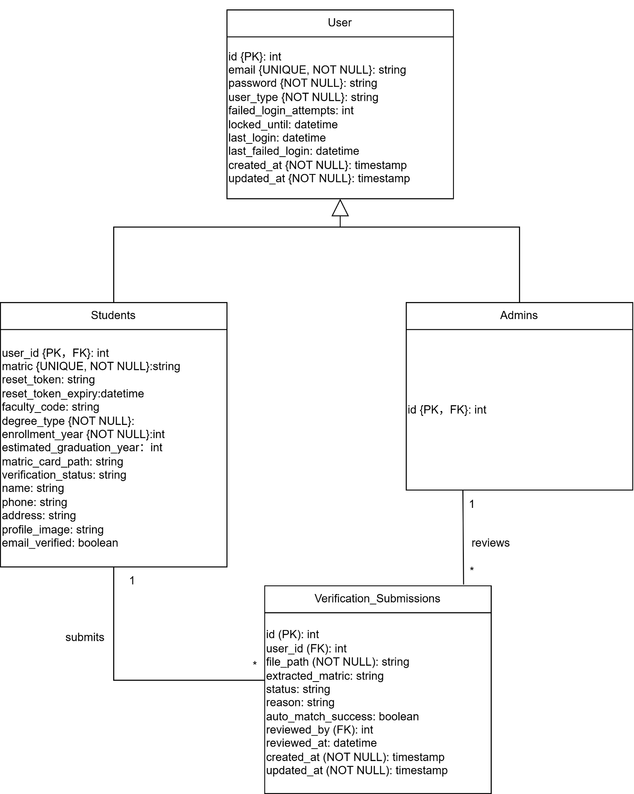
Figure 3.6: Entity Relationship Design (ERD) for Profile and Verification Module

3.2.1.1 DATA DICTIONARY & DESCRIPTION
Entity: User

Attribute name | Data Type | Description
id | int | Primary Key, Auto Increment
email | string | Unique identifier for all users
password | string | Hashed password
user_type | string | Discriminator field
failed_login_attempts | int | Failed login counter
locked_until | datetime | Account lock expiry
last_login | datetime | Last successful login
last_failed_login | datetime | Last failed login
created_at | timestamp | Creation time
updated_at | timestamp | Update time

Table 3.4: Data Dictionary and Description of User Table

Entity: Students

Attribute name | Data Type | Description
id | int | Primary key and foreign key referencing user.id (unique, not null)
user_id | int | Foreign key referencing user.id
matric | string | Unique, student matric number
reset_token | string | Password reset token
reset_token_expiry | datetime | Token expiration
degree_type | string | Degree program
faculty_code | string | Faculty identifier
enrollment_year | int | Year enrolled
estimated_graduation_year | int | Expected graduation year

matric_card_path | string | File path to uploaded matric card image
verification_status | string | Student verification status. Default: 'pending'
name | string | Student's full name
phone | string | Student’s contact phone number
address | string | Student’s residential address
profile_image | string | File path to profile picture
email_verified | boolean | Email verification status. Default: 0 (false)
email_verification_code | string | 6-digit code for email verification
email_code_expiry | datetime | Expiry time for email verification code(1 hour)

Table 3.5: Data Dictionary and Description of Students Table

Entity: Admins

Attribute name | Type | Description
id | int | Primary key and foreign key referencing user.id (unique, not null)
(no additional attributes) |  | Uses only inherited fields

Table 3.6: Data Dictionary and Description of Admins Table

Entity: Verification_Submission

Attribute name | Type | Description
id | int | Primary key. Auto increment
user_id | int | Foreign Key. References Students(user_id)
file_path | string | Path to uploaded matric card

 |  | image. NOT NULL
extracted_matric | string | Matric number extracted via OCR (Tesseract.js)
status | string | Current submission status. Default: 'pending'
reason | string | Reason for flagging or rejection
auto_match_success | boolean | Whether extracted matric matched registered matric. Default: 0
reviewed_by | int | Foreign Key. Admin user_id who reviewed submission
reviewed_at | datetime | Timestamp of admin review
created_at | timestamp | Submission timestamp. Auto-generated
updated_at | timestamp | Last update timestamp. Auto-updates

Table 3.7: Data Dictionary and Description of Verification_Submission Table

3.2.2 USER INTERFACE DESIGN
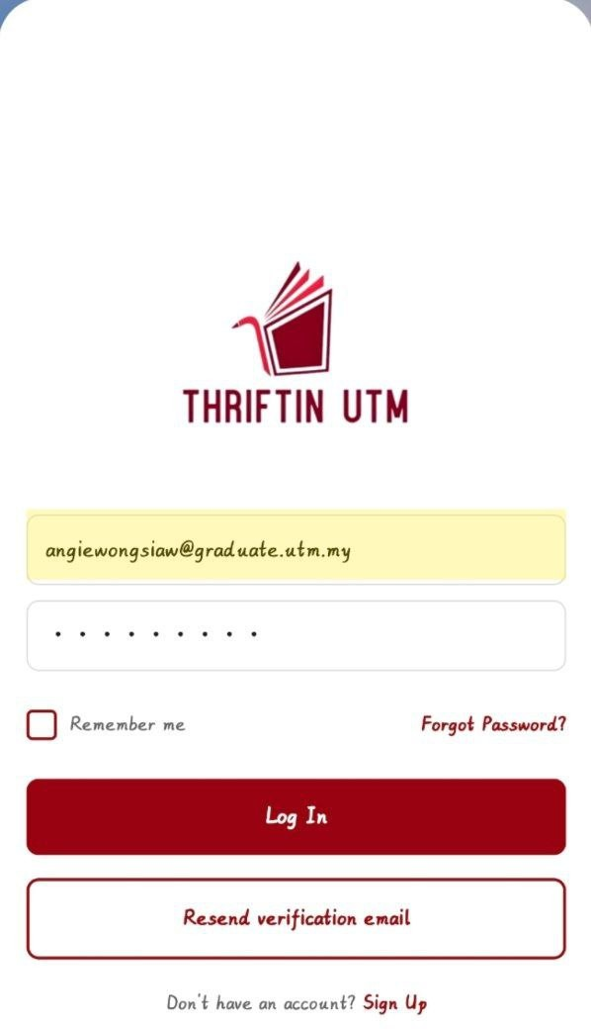

Figure 3.7: User Interface for Require Resend Verification Email

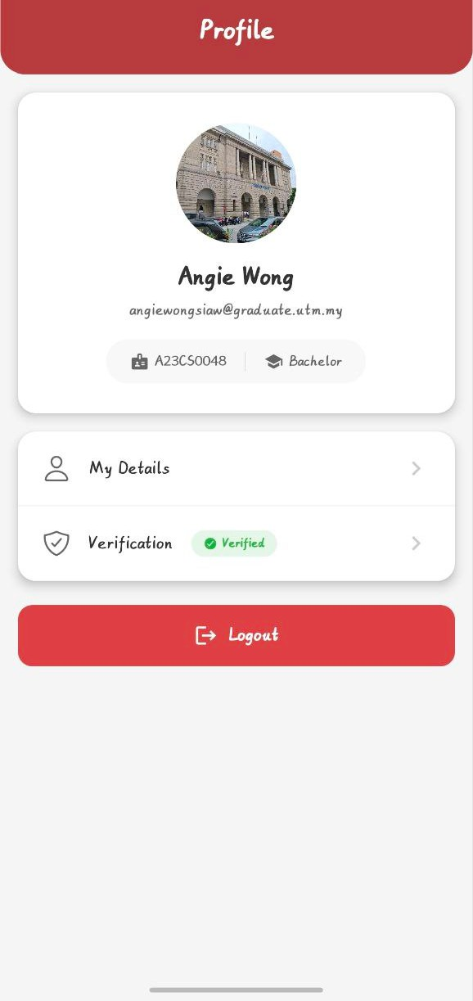
Figure 3.8: User Interface for Profile page

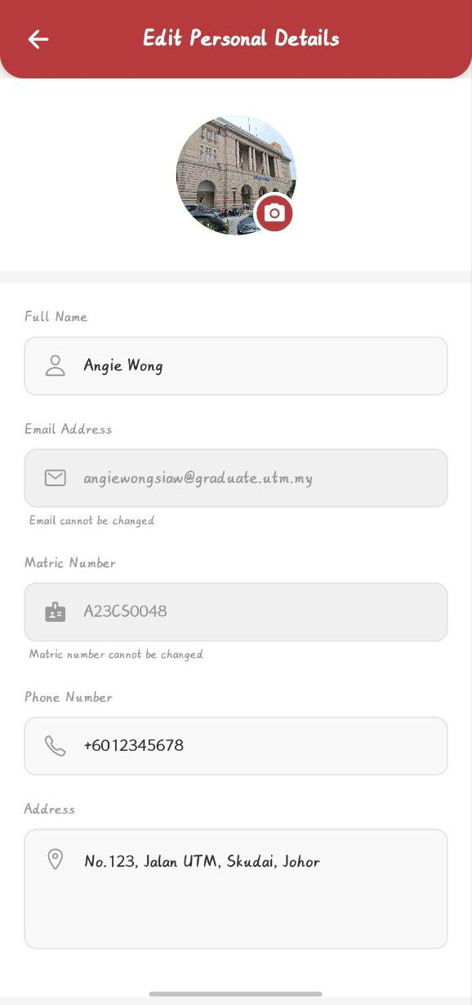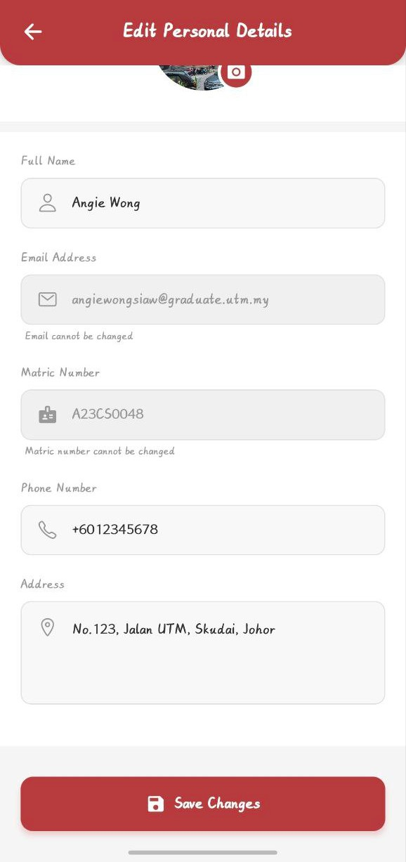
Figure 3.9: User Interface for Edit Personal Details page

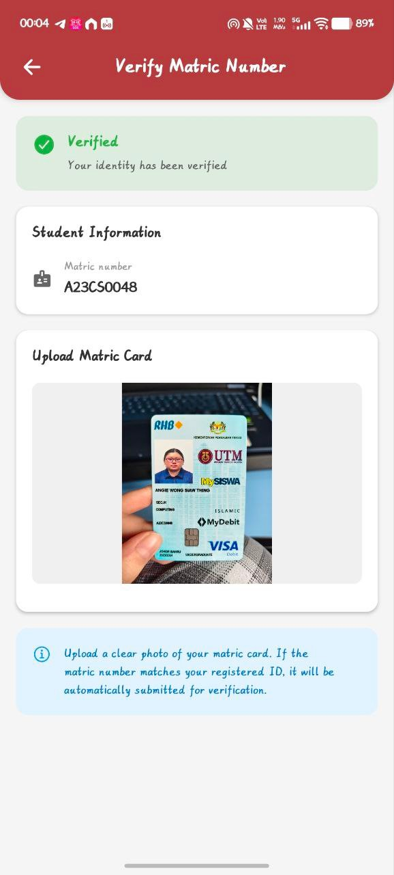
Figure 3.10: User Interface for Verify Matric Number page

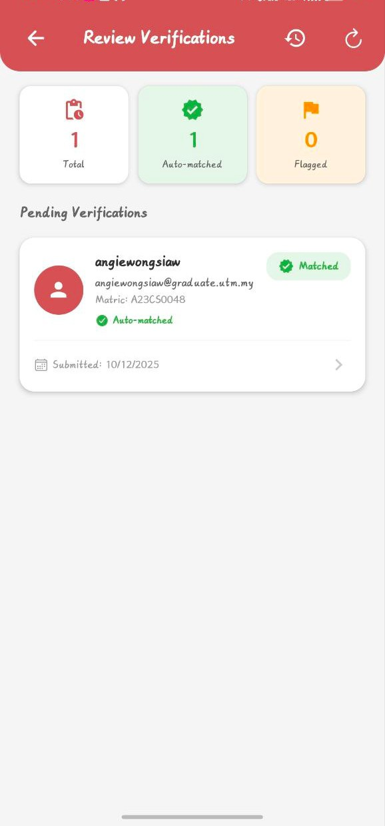

Figure 3.11: User Interface for Review Verifications page

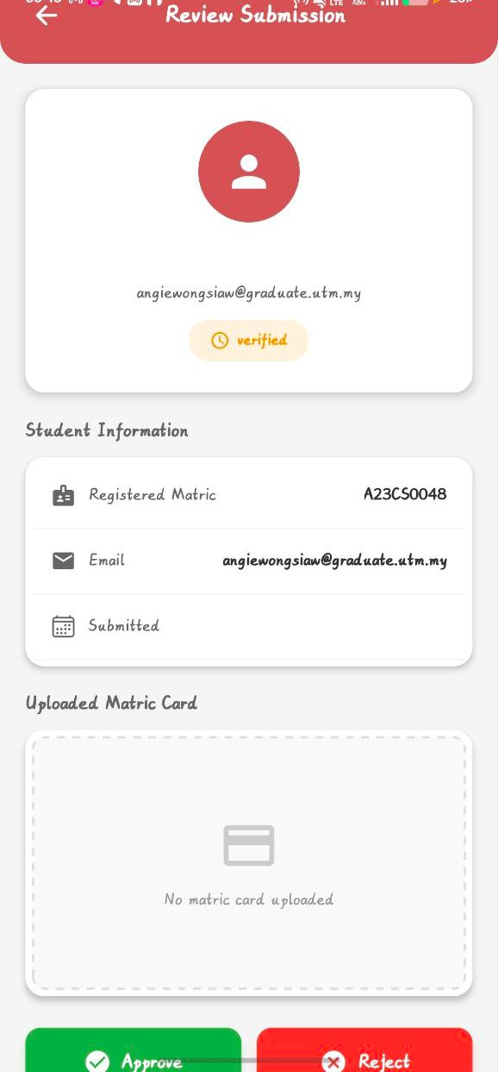
Figure 3.12: User Interface for Review Submission page

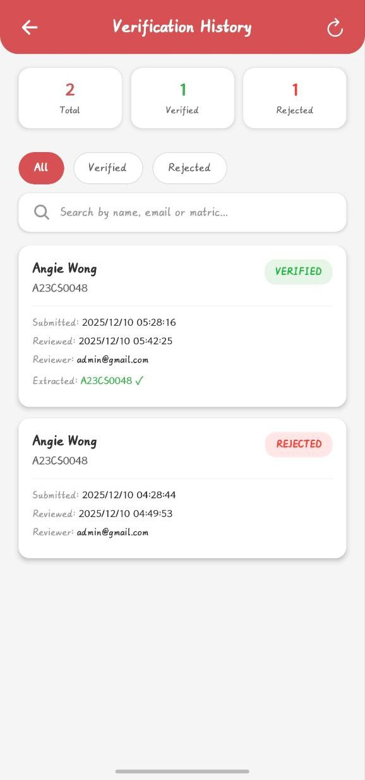
Figure 3.13: User Interface for Verification History page

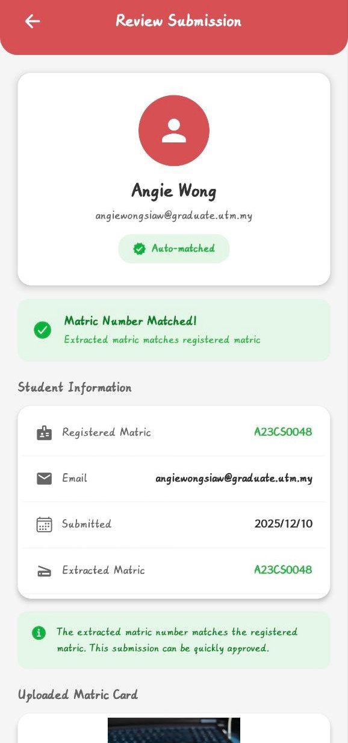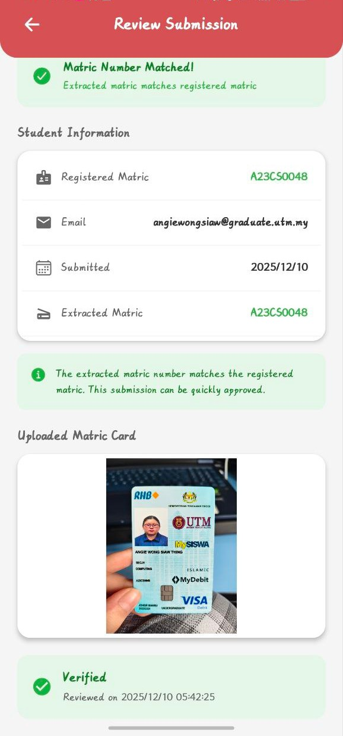
Figure 3.14: User Interface for Review Approved or Rejected Verification page

3.3 ACCESS CONTROL AND AUTHORIZATION MODULE (ANGIE)

3.3.1 DATA DESIGN

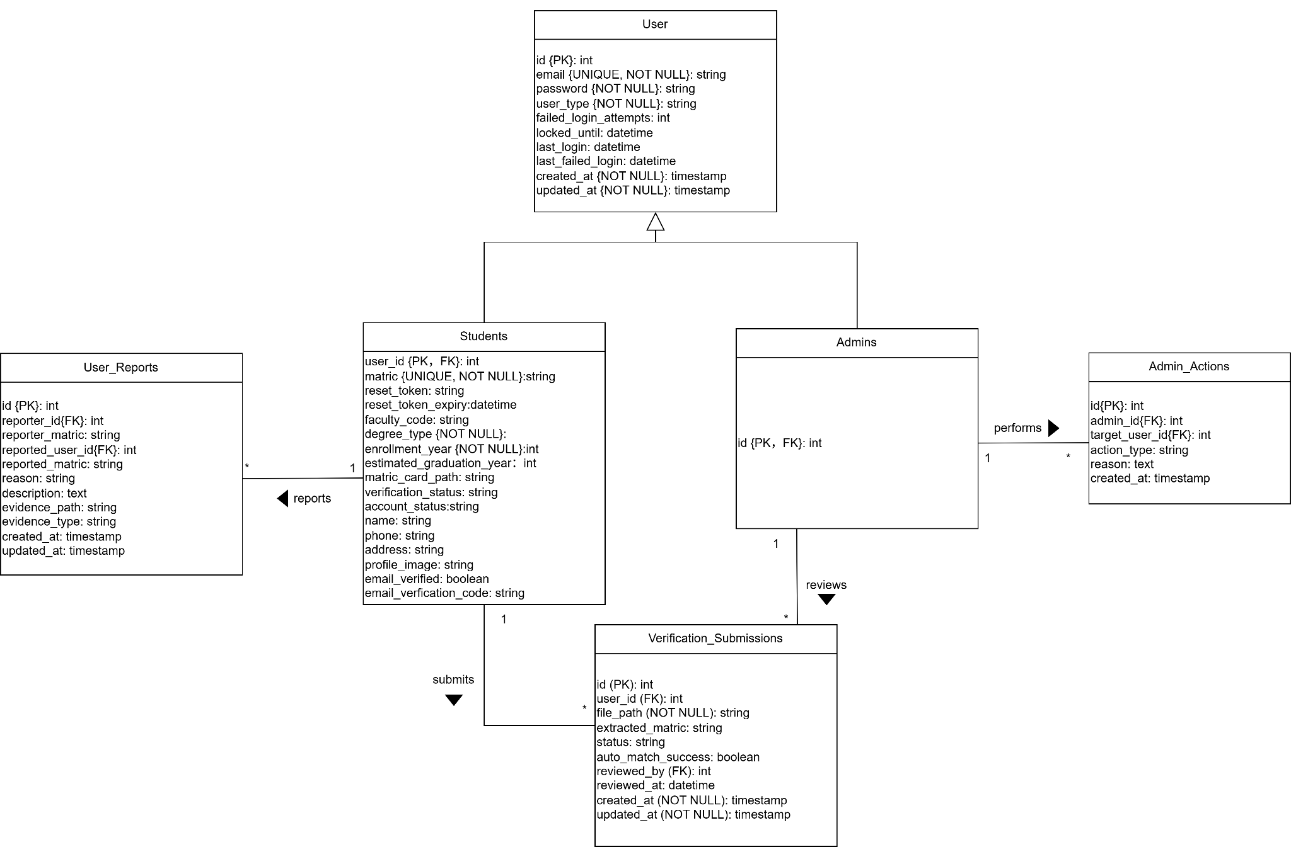
Figure 3.15: Entity Relationship Design (ERD) for Access Control And AuthorizationModule

3.3.1.1 DATA DICTIONARY & DESCRIPTION

Entity: User

Attribute name | Data Type | Description
id | int | Primary Key, Auto Increment
email | string | Unique identifier for all users
password | string | Hashed password
user_type | string | Discriminator field
failed_login_attempts | int | Failed login counter
locked_until | datetime | Account lock expiry
last_login | datetime | Last successful login
last_failed_login | datetime | Last failed login
created_at | timestamp | Creation time
updated_at | timestamp | Update time
Table 3.8: Data Dictionary and Description of User Table

Entity: Students

Attribute name | Data Type | Description
id | int | Primary key and foreign key referencing user.id (unique, not null)
user_id | int | Foreign key referencing user.id
matric | string | Unique, student matric number
reset_token | string | Password reset token
reset_token_expiry | datetime | Token expiration
degree_type | string | Degree program
faculty_code | string | Faculty identifier
enrollment_year | int | Year enrolled

estimated_graduation_year | int | Expected graduation year
matric_card_path | string | File path to uploaded matric card image
verification_status | string | Student verification status. Default: 'pending'
account_status | string | Account status (active/restricted/suspended/pe rmanently_suspended)
name | string | Student's full name
phone | string | Student’s contact phone number
address | string | Student’s residential address
profile_image | string | File path to profile picture
email_verified | boolean | Email verification status. Default: 0 (false)
email_verification_code | string | 6-digit code for email verification
email_code_expiry | datetime | Expiry time for email verification code(1 hour)
Table 3.9: Data Dictionary and Description of Students Table

Entity: Admins

Attribute name | Type | Description
id | int | Primary key and foreign key referencing user.id (unique, not null)
(no additional attributes) |  | Uses only inherited fields
Table 3.10: Data Dictionary and Description of Admins Table

Entity: Verification_Submission

Attribute name | Type | Description

id | int | Primary key. Auto increment
user_id | int | Foreign Key. References Students(user_id)
file_path | string | Path to uploaded matric card image. NOT NULL
extracted_matric | string | Matric number extracted via OCR (Tesseract.js)
status | string | Current submission status. Default: 'pending'
reason | string | Reason for flagging or rejection
auto_match_success | boolean | Whether extracted matric matched registered matric. Default: 0
reviewed_by | int | Foreign Key. Admin user_id who reviewed submission
reviewed_at | datetime | Timestamp of admin review
created_at | timestamp | Submission timestamp. Auto-generated
updated_at | timestamp | Last update timestamp. Auto-updates
Table 3.11: Data Dictionary and Description of Verification_Submission Table

Entity: User_Reports

Attribute name | Type | Description
id | int | Primary key. Auto increment
reporter_id | int | Foreign Key. References user.id (reporter)
reporter_matric | string | Matric number of reporting student
reported_user_id | int | Foreign Key. References user.id (reported user)
reported_matric | string | Matric number of reported student

reason | string | Report reason. NOT NULL
description | text | Detailed description of the issue
evidence_path | string | File path to evidence
evidence_type | string | MIME type of evidence file
created_at | timestamp | Report creation timestamp
updated_at | timestamp | Last update timestamp
Table 3.12: Data Dictionary and Description of User_Reports Table
Entity: Admin_Actions

Attribute name | Type | Description
id | int | Primary key. Auto increment
admin_id | int | Foreign Key. References user.id
target_user_id | int | Foreign Key. References user.id
reported_user_id | int | Foreign Key. References user.id (reported user)
action_type | string | Type of action (temporary_suspension/permanent  _suspension/reinstate). NOT NULL
created_at | timestamp | Action timestamp. Auto-generated
Table 3.13: Data Dictionary and Description of Admin_Actions Table

3.3.2 USER INTERFACE DESIGN
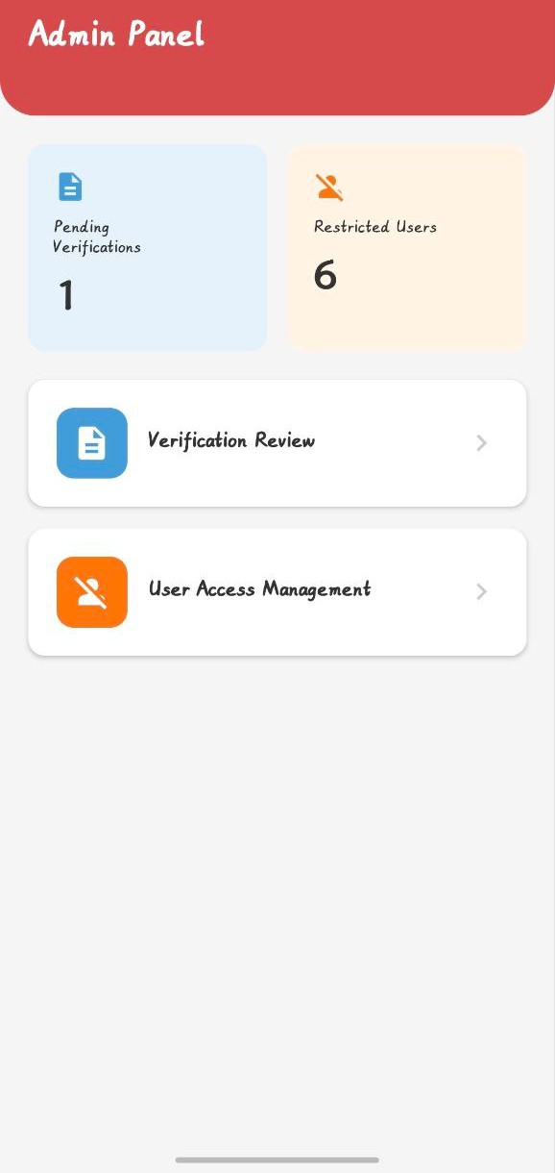
Figure 3.16: Admin Panel Interface

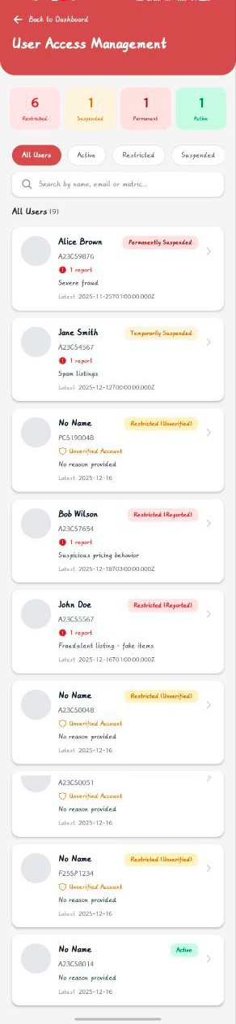
Figure 3.17: User Access Management Interface

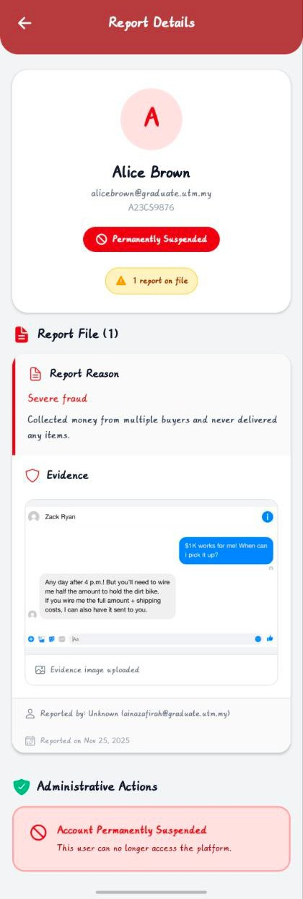
Figure 3.18: Report Details of Permanently Suspended User Interface

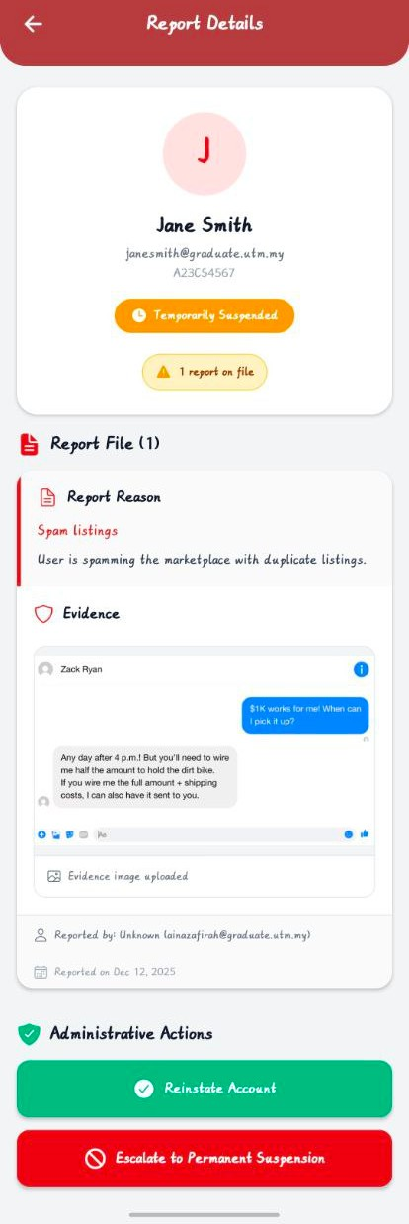
Figure 3.19: Report Details of Temporarily Suspended User Interface

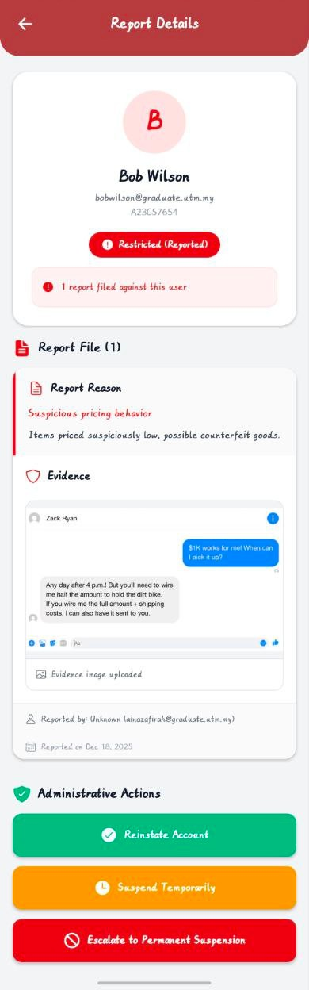
Figure 3.20: Report Details of Restricted(Reported) User Interface

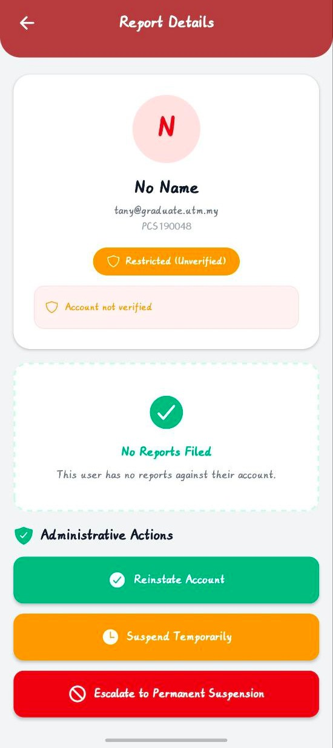
Figure 3.21: Report Details of Restricted(Unverified) User Interface

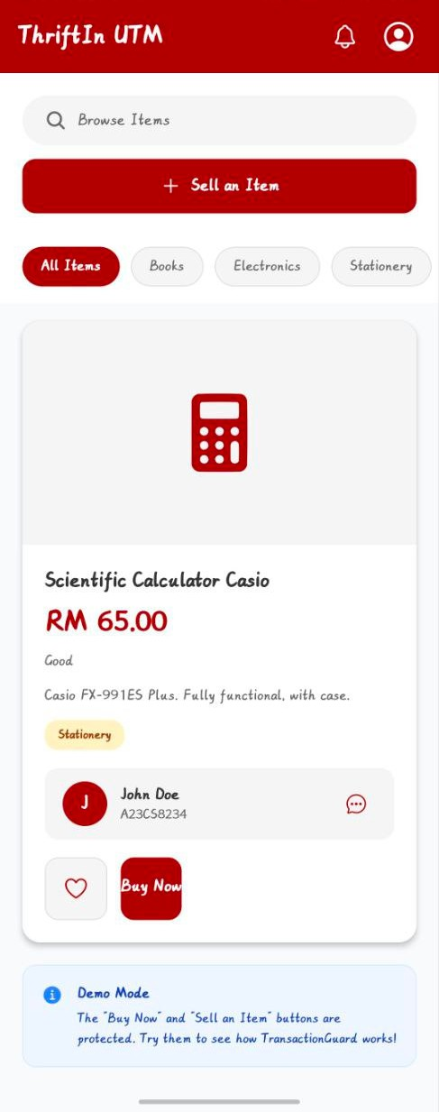
Figure 3.22: Demo Marketplace Interface

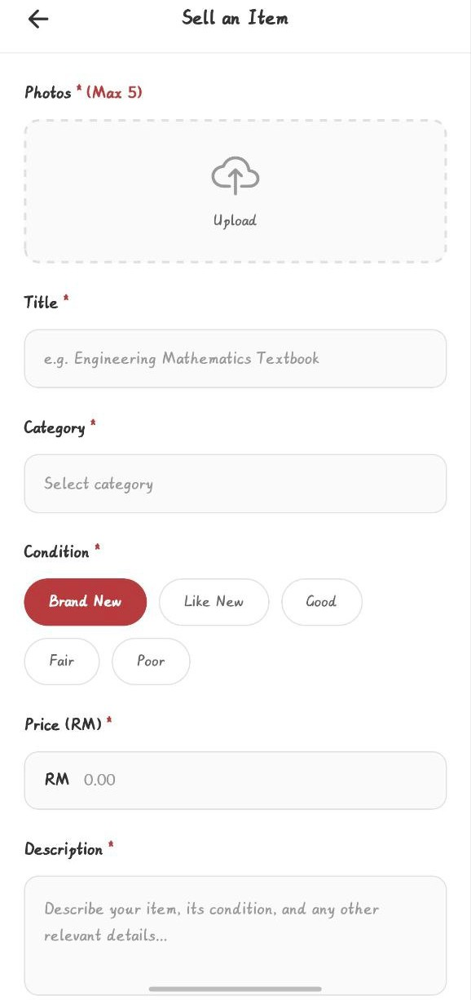
Figure 3.23: Demo Sell Item Interface

4.0 PRODUCT AND MARKET SUBSYSTEM DATA DESIGN

4.1 PRODUCT LISTING & MANAGEMENT MODULE (AINA ZAFIRAH)

4.1.1 DATA DESIGN
The Product Listing & Management module stores information about items listed by students in the marketplace. The main entity is Product, which contains attributes such as name, category, condition, description, and price. Each product can have multiple images stored in a related table which Product Images. The module also references the Users table to ensure that each listing belongs to a valid seller. The data model supports creating, updating, viewing, and deleting products while maintaining data integrity through foreign keys and validation rules.

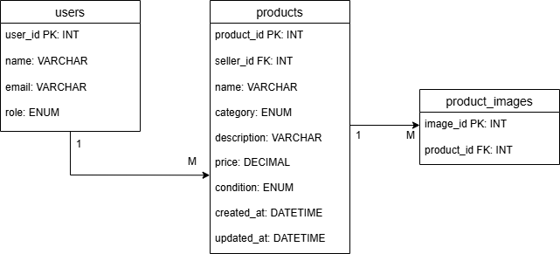

Figure 4.1: Entity Relationship Diagram (ERD) for Product Listing and Management Module

4.1.1.1 DATA DICTIONARY & DESCRIPTION

TABLE 1: PRODUCTS
Attribute Name | Data Type | Description
product_id | INT (PK AUTO_INCREMENT) | Unique identifier for each product
seller_id | INT (FK) | References the student/user who created the listing
name | VARCHAR (150) | Product name (required)
category | ENUM (‘Books’, ‘Electronics’, ‘Fashion’, ‘Furniture’, ‘Others’) | Product category
description | TEXT | Detailed description of the product
price | DECIMAL (10, 2) | Price in RM and must be positive number
condition | ENUM (‘Like New’, ‘Excellent’, ‘Good’, ‘Fair’, ‘Poor’) | Condition of the product

created_at | DATETIME | Timestamp when product was added
updated_at | DATETIME | Timestamp when product was last edited
Table 4.1: Data Dictionary and Description of Products Table TABLE 2: PRODUCT_IMAGES
Attribute Name | Data Type | Description
image_id | INT (PK, AUTO_INCREMENT) | Unique ID for each product image
product_id | INT (FK) | Links image to a product

Table 4.2: Data Dictionary and Description of Product_Images Table

4.1.2 USER INTERFACE DESIGN
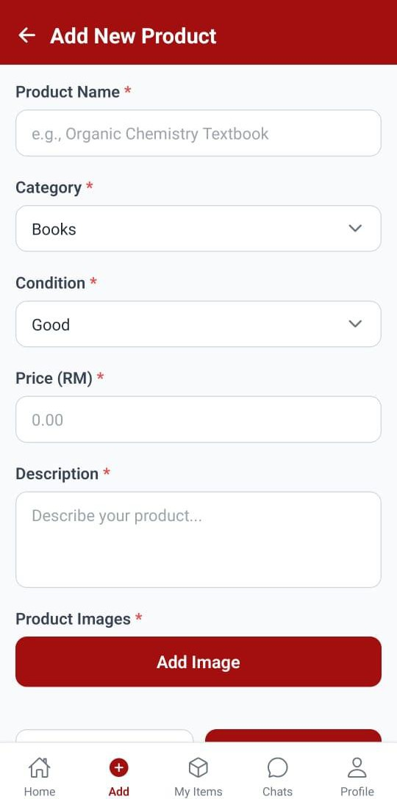
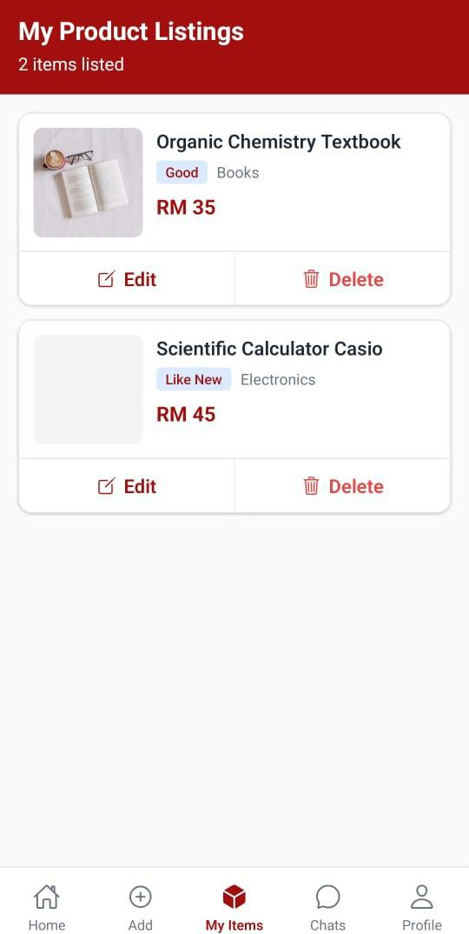
Figure 4.2 User Interface Design for Add Product and View Own Product Listing

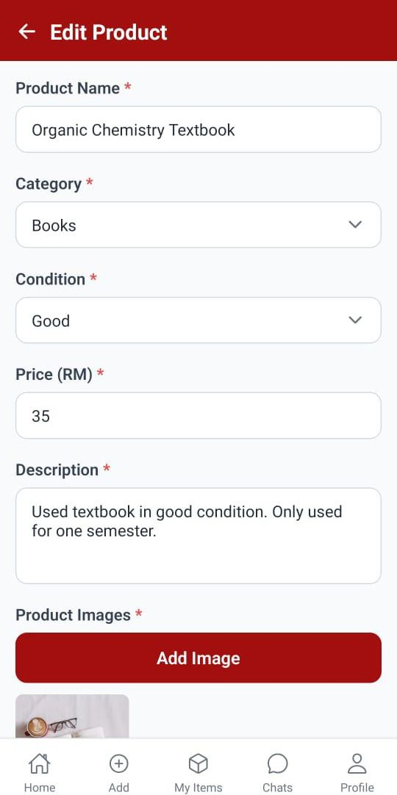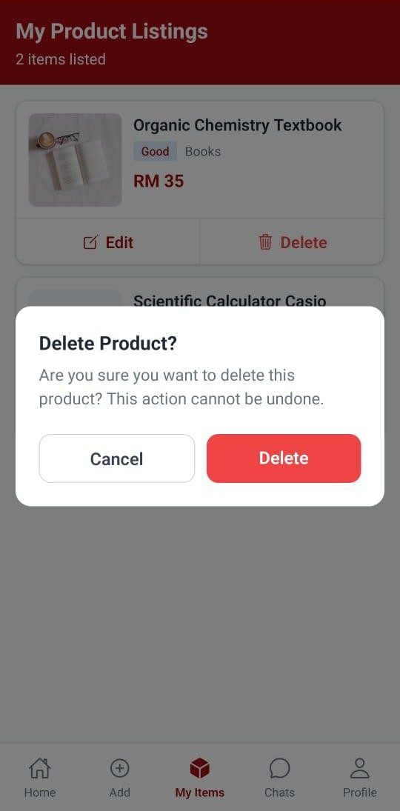
Figure 4.3 User Interface Design for Edit Product Details and Delete Product

4.2 PRODUCT AND MARKET SUBSYSTEM: SEARCH AND RECOMMENDATION MODULE (AINA ZAFIRAH)

4.2.1 DATA DESIGN

The Search and Recommendation Module extends the existing product database with two new tables to support view recommendations. The user_interactions table tracks every product view, search, and click action performed by students, storing the user_id, product_id, interaction type, and timestamp. The search_history table records all search queries made by students along with the number of results returned and the search timestamp. These tables enable the recommendation algorithm to analyze user behavior patterns and provide personalized suggestions. The module also adds a view_count column to the existing products table to track product popularity. This counter is incremented every time a student views a product's details, helping the system identify trending items. The recommendation algorithm uses this data in combination with user interaction history to suggest relevant products. The data model maintains referential integrity through foreign key constraints linking to the users and products tables. Indexes are created on frequently queried columns (user_id, product_id, created_at) to optimize search and recommendation query performance. All timestamps use DATETIME type for consistent temporal tracking across the system.

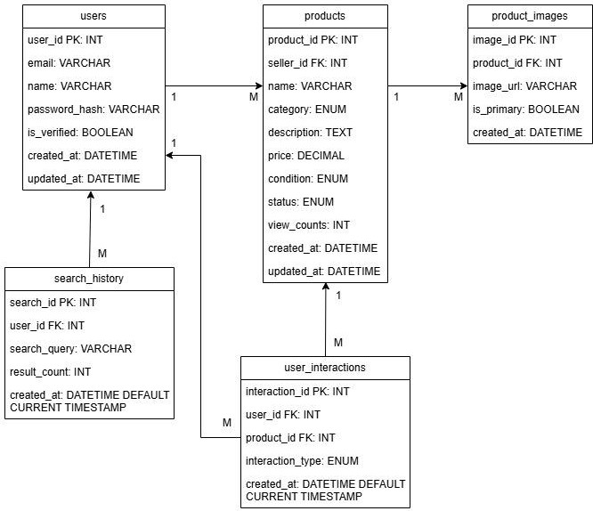

Figure 4.4: Entity Relationship Diagram (ERD) for Search and Recommendation Module

DATA DICTIONARY & DESCRIPTION

TABLE 1: USER_INTERACTIONS ( NEW)
Attribute Name | Data Type | Description
interaction_id | INT (PK, AUTO_INCREMENT) | Unique identifier for each interaction
user_id | INT (FK) | References the student who performed the action
product_id | INT (FK) | References the product that was interacted with
interaction_type | ENUM (‘view’, ‘search’, ‘click’) | Type of interaction performed
created_at | DATETIME DEFAULT CURRENT_TIMESTAMP | Timestamp when interaction occured

Table 4.3: Data Dictionary for User_Interactions table

TABLE 2: SEARCH_HISTORY (NEW)

Attribute Name | Data Type | Description
search_id | INT (PK, AUTO_INCREMENT) | Unique identifier for each search
user_id | INT (FK) | References the student who performed the search
search_query | VARCHAR (255) NOT NULL | The search keyword entered by student
result_count | INT DEFAULT 0 | Number of product found for this search
created_at | DATETIME DEFAULT CURRENT_TIMESTAMP | Timestamp when search was performed
Table 4.4: Data Dictionary for Search_History table

TABLE 3: PRODUCTS (MODIFIED - ADDED COLUMN)

Attribute Name | Data Type | Description
view_count | INT DEFAULT 0 | Number of times product details have been viewed
Table 4.5: Data Dictionary for new column in Products table

TABLE 4: PRODUCTS (EXISTING - USED FOR QUERIES)
Attribute Name | Data Type | Description
product_id | INT (PK AUTO_INCREMENT) | Unique identifier for each product
seller_id | INT (FK) | References the student/user who created the listing
name | VARCHAR (150) | Product name (required)
category | ENUM (‘Books’, ‘Electronics’, ‘Fashion’, ‘Furniture’, ‘Others’) | Product category
description | TEXT | Detailed description of the product
price | DECIMAL (10, 2) | Price in RM and must be positive number
condition | ENUM (‘Like New’, ‘Excellent’, ‘Good’, ‘Fair’, ‘Poor’) | Condition of the product
status | ENUM (“active”, “sold”, “deleted”) | Current status of the product
view_counts | INT DEFAULT 0 | [ADDED] Number of views
created_at | DATETIME | Timestamp when product was added
updated_at | DATETIME | Timestamp when product was last edited
Table 4.6: Data Dictionary for Products table

TABLE 5: PRODUCT_IMAGES (EXISTING - USED FOR DISPLAY)
Attribute Name | Data Type | Description
image_id | INT (PK, AUTO_INCREMENT) | Unique ID for each product image
product_id | INT (FK) | Links image to a product
image_url | VARCHAR (500) NOT NULL | Path to the image file
is_primary | BOOLEAN DEFAULT FALSE | Whether this is the main product image
created_at | DATETIME | Timestamp when image was uploaded
Table 4.7: Data Dictionary for Product_Images table

TABLE 6: USERS (EXISTING - USED FOR SELLER INFO)
Attribute Name | Data Type | Description
user_id | INT (PK, AUTO_INCREMENT) | Uniques identifier for each user
email | VARCHAR (100) UNIQUE NOT NULL | UTM email address
name | VARCHAR (100) NOT NULL | User’s full name
password_hash | VARCHAR (100) NOT NULL | Encrypted password
is_verified | BOOLEAN DEFAULT FALSE | Email verification status
created_at | DATETIME | Account creation timestamp
updated_at | DATETIME | Last update timestamp
Table 4.8: Data Dictionary for Users table

4.2.2 USER INTERFACE DESIGN
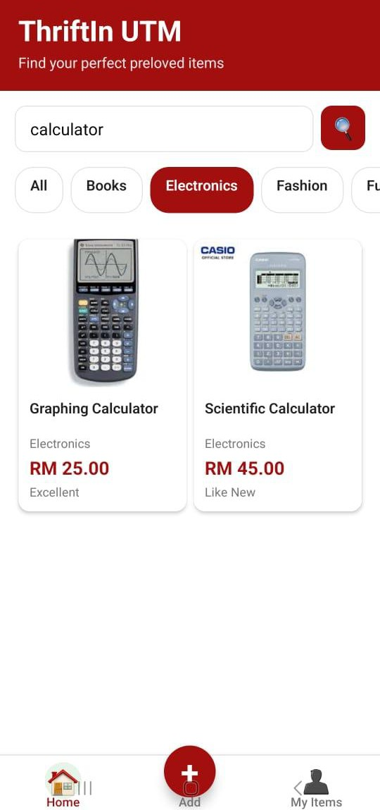
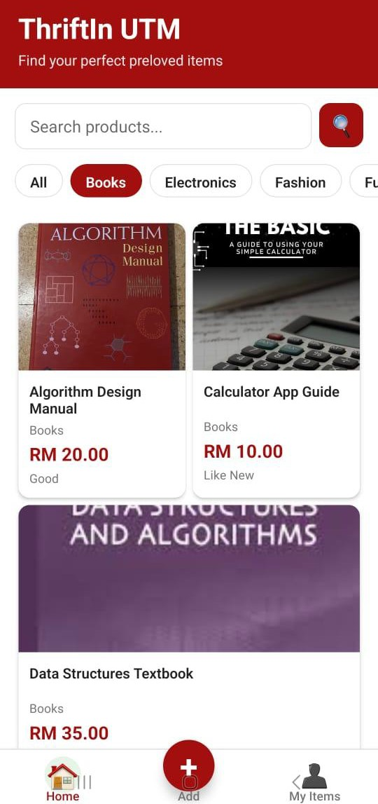

Figure 4.5: User interface for UC019 Search Product and UC020 Filter Product by Category

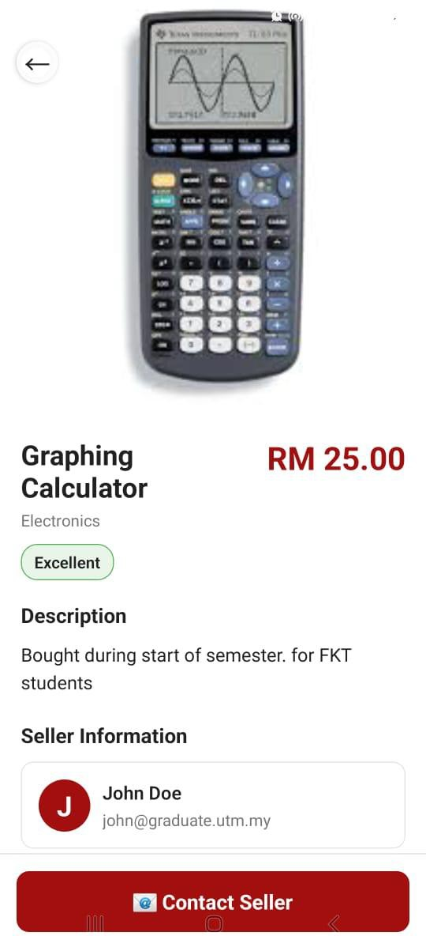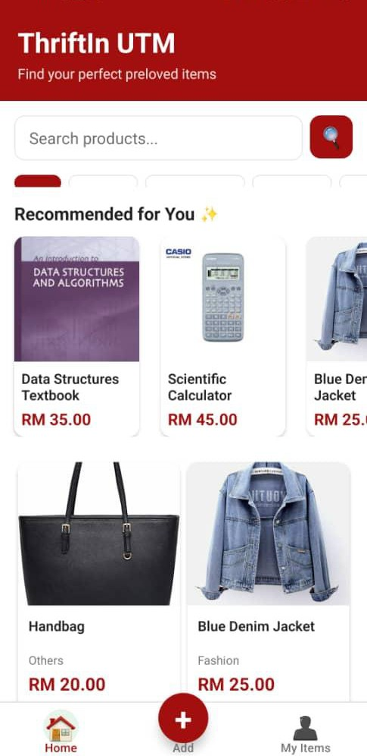
Figure 4.6: User interface for UC21 View Product Details and UC021 View Product Recommendation

4.3. PURCHASING AND PAYMENT MODULE (AINA ZAFIRAH)

4.3.1 DATA DESIGN

The Purchasing and Payment Module with MyWallet introduces four new tables to handle the complete wallet and transaction lifecycle. The wallets table stores each user’s virtual wallet balance. Each user has one wallet with a unique wallet_id. The balance field tracks the current amount available for purchases. The table includes timestamps for wallet creation and last update. A CHECK constraint ensures balance never goes negative. The wallet_transactions table maintains a complete audit trail of all wallet activities. It records three transaction types: ‘top_up’ (adding money), ‘purchase’ (buying items), and ‘refund’ (cancelled order refunds). Each transaction captures the balance before and after the operation, ensuring complete financial transparency. For top-ups, it stores the payment method used. For purchases and refunds, it links to the order_id and stores the product name for reference. The orders table records completed purchases with order metadata including buyer_id, total_amount for purchases, and payment_method. The order_status tracks whether orders are ‘completed’ or ‘cancelled’. The cancelled_at timestamp records when cancellations occur. The order_items table maintains detailed information about each purchased product, storing a snapshot of product details at time of purchase to maintain historical accuracy even if the original product is later modified or deleted. It includes product_name, product_price, product_category, product_condition, product_description, and seller information (seller_id, seller_name, seller_email). The module uses the existing products table's status field effectively. When a product is purchased through “Buy Now”, its status changes from ‘active’ to ‘sold’, immediately removing it from marketplace listings. When an order is cancelled, the status returns to ‘active’, making it available again.

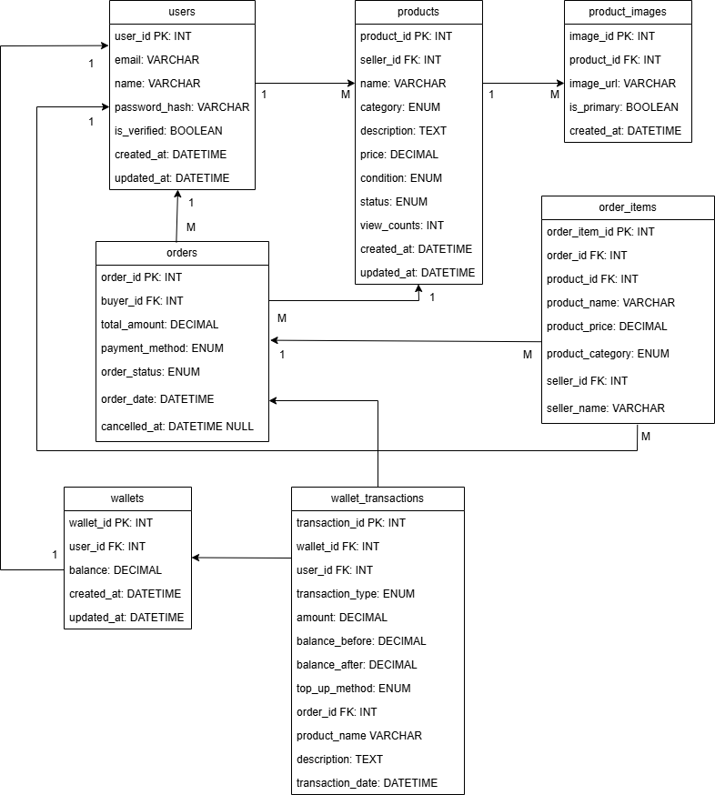
Figure 4.7: Entity Relationship Diagram (ERD) for Purchasing and Payment Module

4.3.1.1 DATA DICTIONARY & DESCRIPTION

TABLE 1: WALLETS (NEW)
Attribute Name | Data Type | Description
wallet_id | INT (PK, AUTO_INCREMENT) | Unique identifier for each wallet
user_id | INT (FK, UNIQUE) | References the student who owns the wallet
balance | DECIMAL(10, 2) NOT NULL DEFAULT 0.00 | Current wallet balance
created_at | DATETIME DEFAULT CURRENT_TIMESTAMP | When wallet was created
updated_at | DATETIME DEFAULT CURRENT_TIMESTAMP ON UPDATE CURRENT_TIMESTAMP | When balance was last updated
Table 4.9: Data Dictionary for (New) Wallets table

TABLE 2: WALLET_TRANSACTIONS (NEW)

Attribute Name | Data Type | Description
transaction_id | INT (PK, AUTO_INCREMENT) | Unique identifier for each transaction
wallet_id | INT (FK) | References the wallet
user_id | INT (FK) | References the user for easier queries
transaction _type | ENUM(‘top_up’, ‘purchase’, ‘refund’) NOT NULL | Type of transaction
amount | DECIMAL(10, 2) NOT NULL | Transaction amount
balance_before | DECIMAL(10, 2) NOT NULL | Balance before transaction
balance_after | DECIMAL(10, 2) NOT NULL | Balance after transaction
top_up_method | ENUM(‘credit_card’, ‘e_wallet’, ‘online_banking’) NULL | Payment method for top-ups
order_id | INT (FK) NULL | References order for purchase or refunds
product_name | VARCHAR(150) NULL | Product name for purchases or refunds
description | TEXT NULL | Transaction description

transaction_date | DATETIME DEFAULT CURRENT_TIMESTAMP | When transaction occured
Table 4.10: Data Dictionary for (New) Wallet_Transactions table
TABLE 3: ORDERS (NEW)

Attribute Name | Data Type | Description
order_id | INT (PK, AUTO_INCREMENT) | Unique identifier for each order
buyer_id | INT (FK) | References the student who made the purchase
total_amount | DECIMAL(10, 2) NOT NULL | Total price of all items in order
payment_method | ENUM(‘credit_card’, ‘e_wallet’, ‘online_banking’, ‘wallet’) NOT NULL | Payment method used (always 'wallet' in current system)
order_status | ENUM(‘completed’, ‘cancelled’, ‘refunded’) DEFAULT ‘completed’ | Current status of order
order_date | DATETIME DEFAULT CURRENT_TIMESTAMP | When order was placed
cancelled_at | DATETIME NULL | When order was cancelled
Table 4.11: Data Dictionary for (New) Orders table

TABLE 4: ORDER_ITEMS (NEW)

Attribute Name | Data Type | Description
order_item_id | INT (PK, AUTO_INCREMENT) | Unique identifier for each item in order
order_id | INT (FK) | References the parent order
product_id | INT (FK) | References the original product
product_name | VARCHAR(150) NOT NULL | Snapshot of product name at purchase time
product_price | DECIMAL(10, 2) NOT NULL | Snapshot of price at purchase time
product_category | VARCHAR(50) | Snapshot of category at purchase time
seller_id | INT (FK) | Snapshot of seller at purchase time

seller_name | VARCHAR(100) | Snapshot of seller name at purchase time
Table 4.12: Data Dictionary for (New) Order_Items table

TABLE 5: PRODUCTS (MODIFIED - ADDED COLUMN)

Attribute Name | Data Type | Description
status | ENUM('active', 'sold', 'deleted') DEFAULT 'active' | Product availability status
Table 4.13: Data Dictionary for modified column in Products table

4.3.2 USER INTERFACE DESIGN

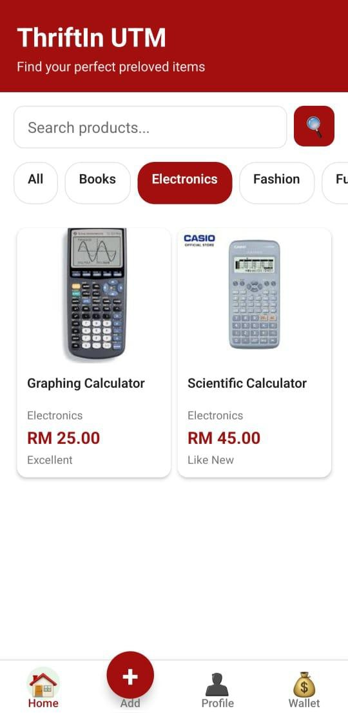
Figure 4.8: User Interface Design for Updated Navigation with Wallet Tab

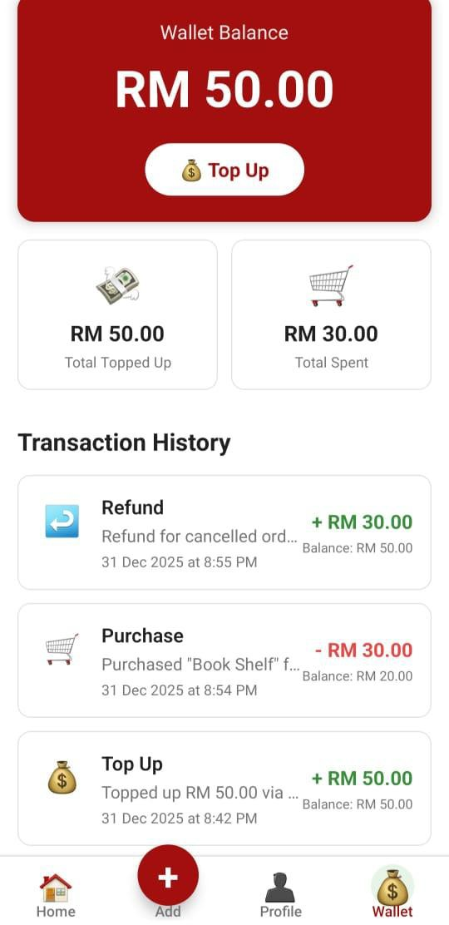
Figure 4.9: User Interface Design for MyWallet Screen showing Balance and Transaction History
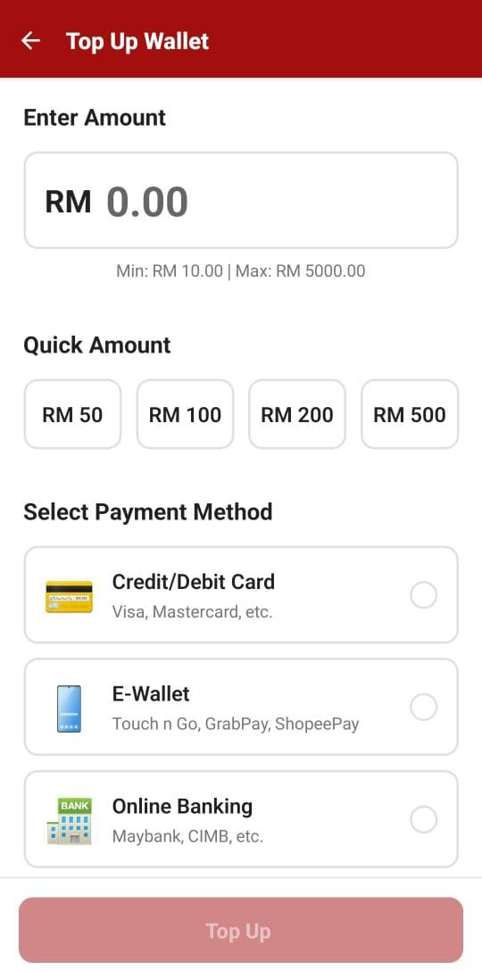
Figure 4.10: User Interface Design for Top Up Wallet Screen with Payment Method Selection

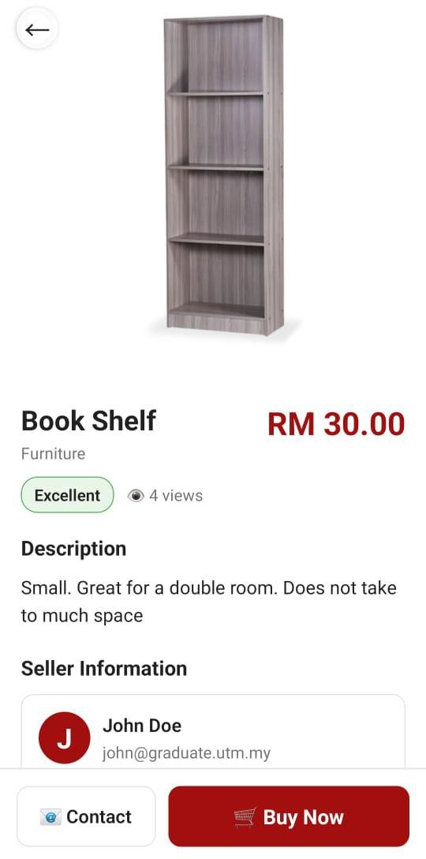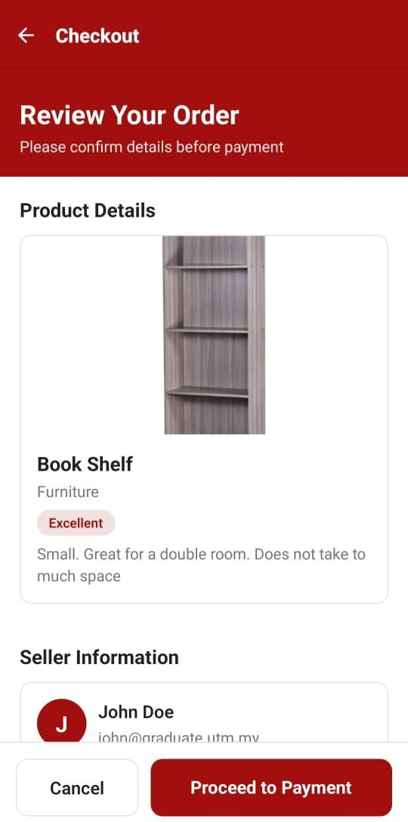
Figure 4.11: User Interface Design for Buy Now feature and Checkout Screen

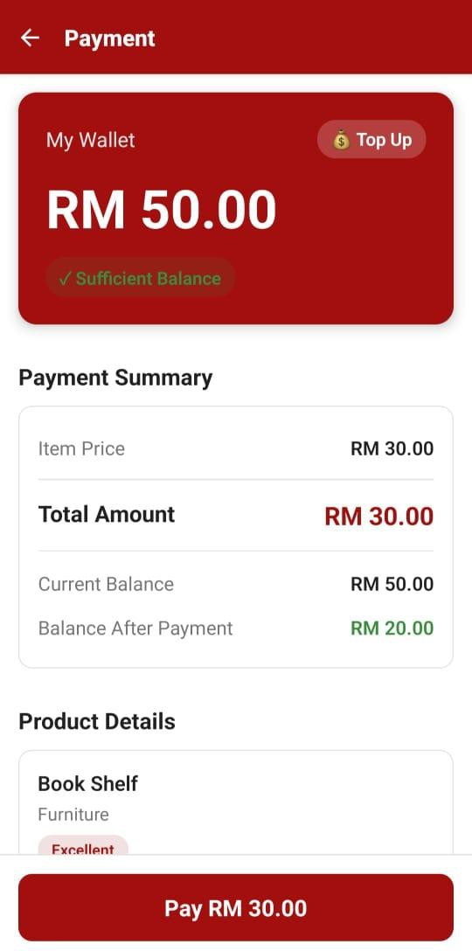

Figure 4.12: User Interface Design for Payment Screen with Wallet Balance Check
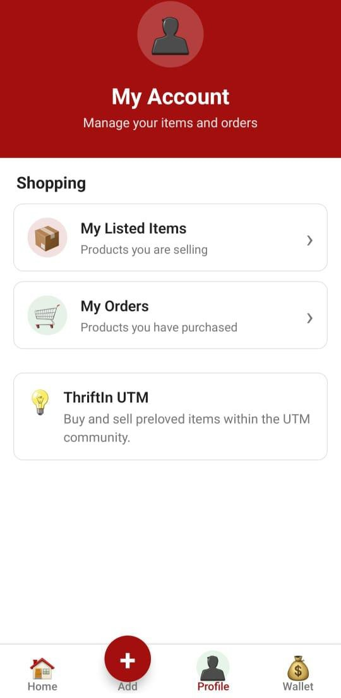
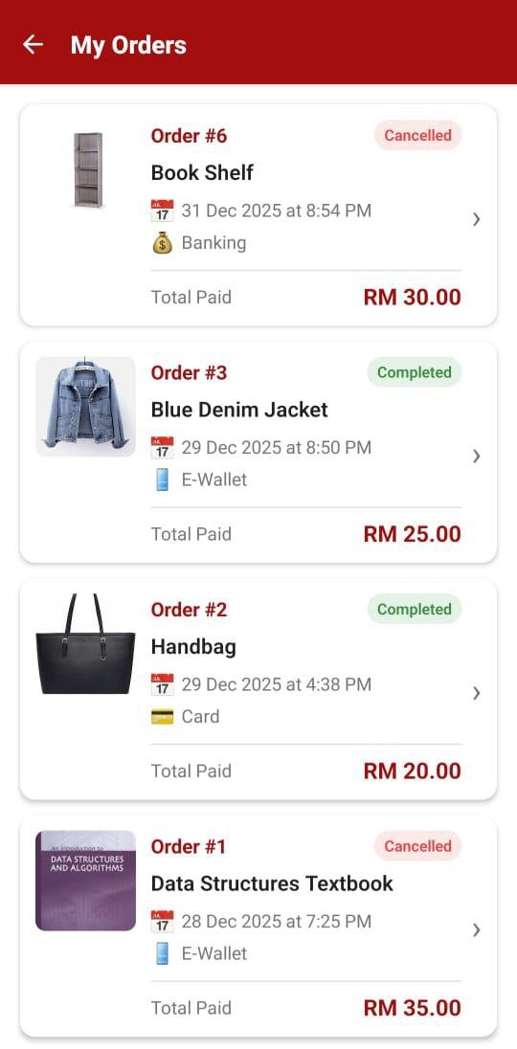
Figure 4.13: User Interface Design for Profile Screen and Order History Screen

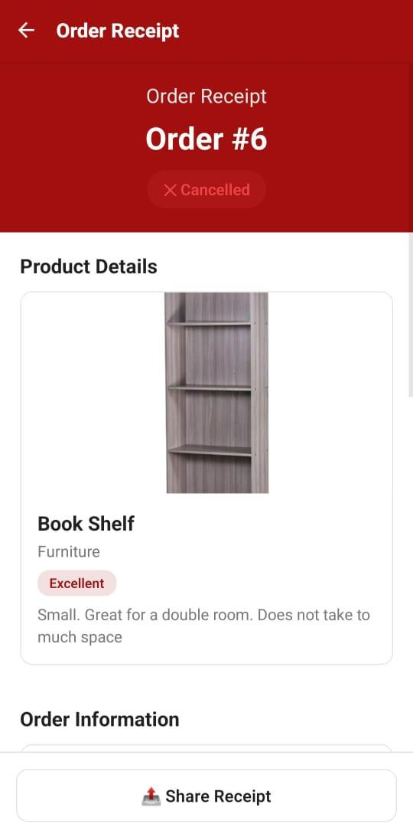
Figure 4.14: User Interface Design for Order Receipt Screen with Wallet Payment Info

5.0 ANALYTICS AND INSIGHTS SUBSYSTEM DATA DESIGN

5.1 USER ACTIVITY DASHBOARD MODULE (ASILAH)

5.1.1 DATA DESIGN

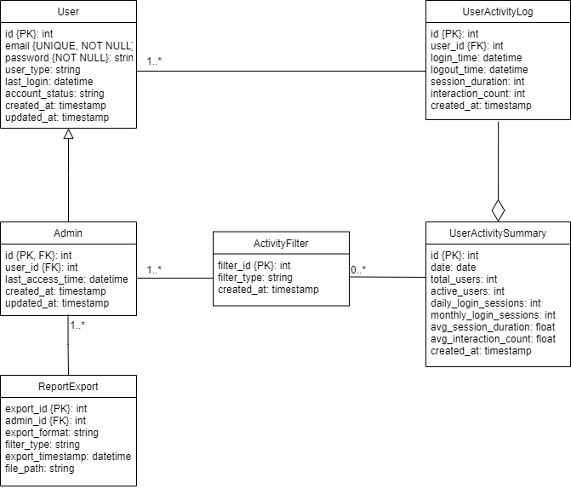
Figure 5.1: Entity Relationship Design (ERD) for User Activity Dashboard Module

5.1.1.1 DATA DICTIONARY & DESCRIPTION
- Admin

Attribute Name | Data Type | Description
id | int | Primary key, auto increment
user_id | int | Foreign key referencing user.id
last_access_time | datetime | Last time admin accessed the analytics dashboard
created_at | timestamp | Admin role creation timestamp
updated_at | timestamp | Last role update time
Table 5.1: Data Dictionary and Description of Admin Table

- User

Attribute Name | Data Type | Description
id | int | Primary key, auto increment
email | string | Unique email for user login
password | string | Hashed password for authentication
user_type | string | Role type: student, admin, or other
last_login | datetime | Timestamp of last successful login
account_status | string | Account state: active / suspended / inactive
created_at | timestamp | User account creation time
updated_at | timestamp | Last update time of user information
Table 5.2: Data Dictionary and Description of User Table
- Admin

Attribute Name | Data Type | Description
id | int | Primary key, auto increment
user_id | int | Foreign key referencing user.id
last_access_time | datetime | Last time admin accessed the analytics dashboard
created_at | timestamp | Admin role creation timestamp
updated_at | timestamp | Last role update time
Table 5.3: Data Dictionary and Description of Admin Table
- UserActivityLog

Attribute Name | Data Type | Description
id | int | Primary key, auto increment
user_id | int | Foreign key referencing user.id
login_time | datetime | Timestamp when user logs into the app
logout_time | datetime | Timestamp when user logs out
session_duration | int | Duration of the session in minutes
interaction_count | int | Number of interactions performed during session

created_at | timestamp | Record creation time
Table 5.4: Data Dictionary and Description of User Activity Log Table
- UserActivitySummary

Attribute Name | Data Type | Description
id | int | Primary key, auto increment
date | date | Date of the summarized activity
total_users | int | Total number of registered users up to that date
active_users | int | Users who logged in within the last 7 days
daily_login_sessions | int | Total login sessions for that particular day
monthly_login_sessions | int | Aggregated login sessions for the month
avg_session_duration | float | Average session duration (minutes)
avg_interaction_count | float | Average user interaction count
created_at | timestamp | Summary record creation time
Table 5.5: Data Dictionary and Description of User Activity Summary Table
- ActivityFilter

Attribute Name | Data Type | Description
filter_id | int | Primary key
filter_type | string | Type of filter: Today, This Month, All Time
created_at | timestamp | Filter creation timestamp
Table 5.6: Data Dictionary and Description of Activity Filter Table
- ReportExport

Attribute Name | Data Type | Description
export_id | int | Primary key
admin_id | int | Foreign key referencing admins.id
export_format | string | File format (PDF)
filter_type | string | Date filter used during export

export_timestamp | datetime | Date and time when export was generated
file_path | string | Location of exported report file
Table 5.6: Data Dictionary and Description of Report Export Table

5.1.2 USER INTERFACE DESIGN
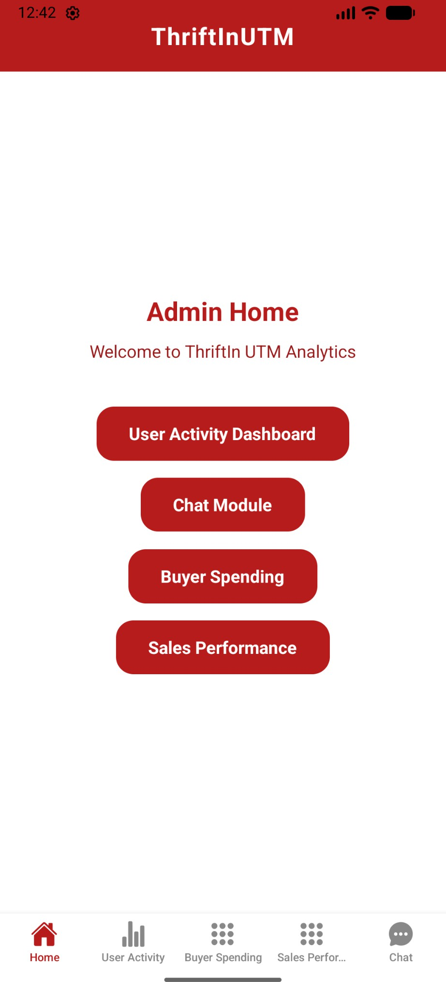
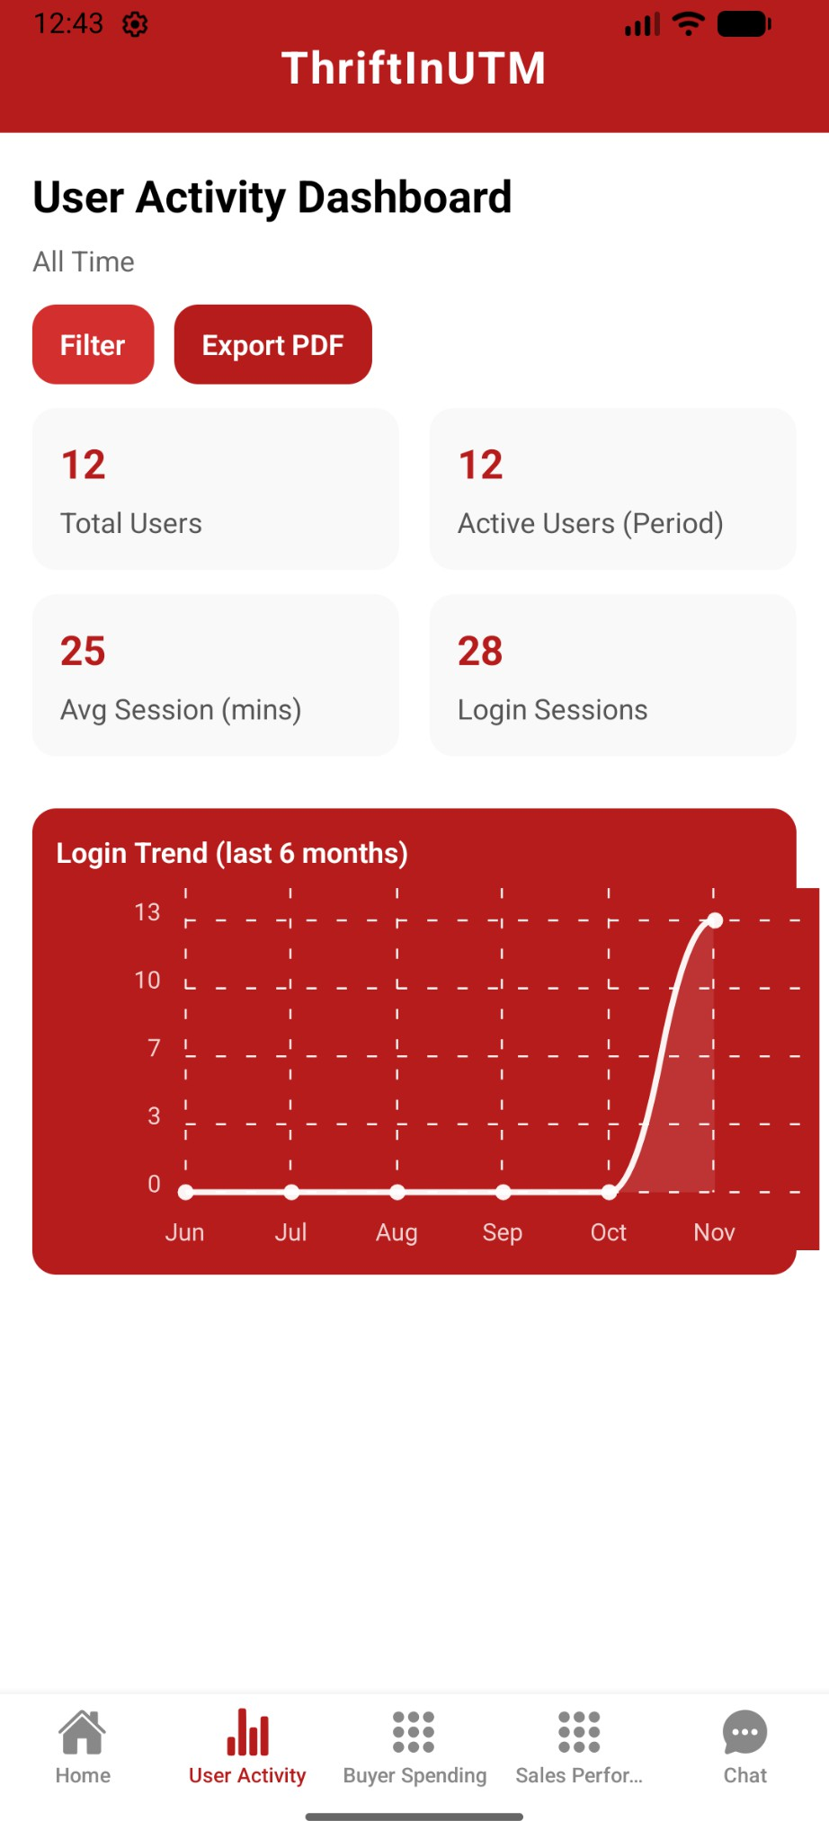
Figure 5.2 User Interface Design for Admin Home page and User Activity Dashboard page

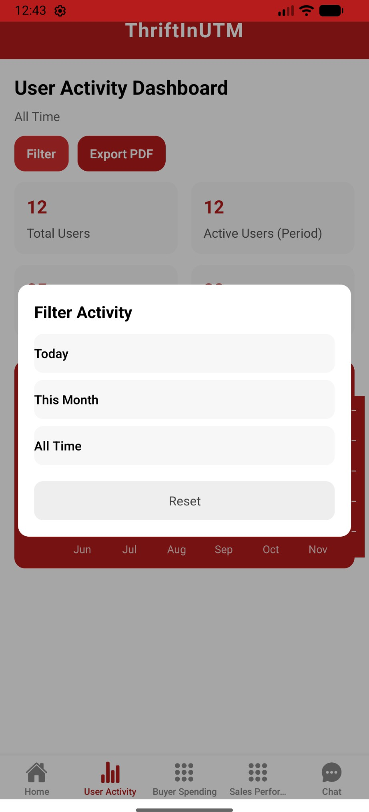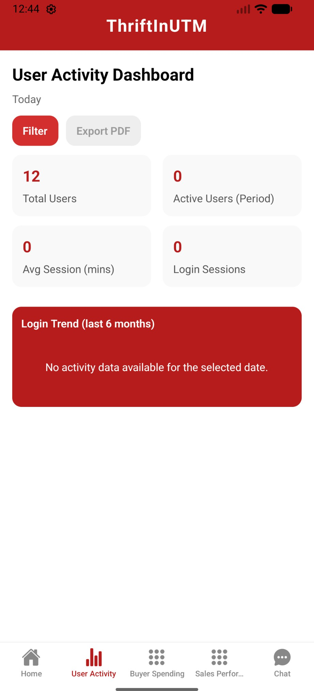
Figure 5.3 User Interface Design for User Activity Dashboard Filter page and User Activity Dashboard (No Data Available) page

5.2 SALES & PERFORMANCE MODULE (ASILAH)

5.2.1 DATA DESIGN

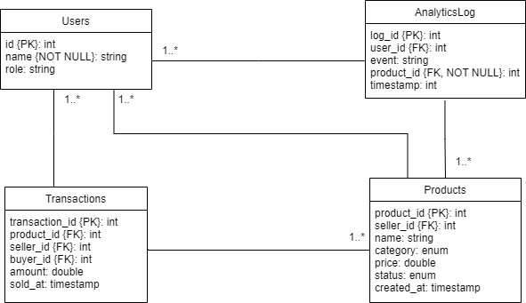
Figure 5.4: Entity Relationship Design (ERD) for Sales and Performance Module

5.2.1.1 DATA DICTIONARY & DESCRIPTION
      - Users

Attribute Name | Data Type | Description
user_id | int | Unique identifier for each user
name | string | Name of the user
user_type | string | Type of the user in the system
Table 5.7: Data Dictionary and Description of Users Table

      - Products

Attribute Name | Data Type | Description
product_id | int | Unique identifier for each product
seller_id | int | References the user who listed the product
name | string | Name of the product
category | string | Category of the product
price | double (decimal(10,2)) | Price of the product
status | string | Current status of the product

created_at | timestamp | Timestamp when the product was created/listed
Table 5.8: Data Dictionary and Description of Products Table

      - Transactions

Attribute Name | Data Type | Description
transaction_id | int | Unique identifier for each transaction
product_id | int | References the product sold
seller_id | int | References the seller of the product
buyer_id | int | References the buyer of the product
amount | double (decimal(10,2)) | Total amount for the transaction
sold_at | timestamp | Timestamp when the transaction occurred
Table 5.9: Data Dictionary and Description of Transactions Table

      - AnalyticsLogs

Attribute Name | Data Type | Description
log_id | int | Unique identifier for each analytics log entry
user_id | int | References the user who performed the action
event | string | Type of event performed by the user such as view, click, purchase
product_id | int | References the product involved in the event (if applicable)
timestamp | datetime | Timestamp when the event occurred
Table 5.10: Data Dictionary and Description of AnalyticsLogs Table

5.2.2 USER INTERFACE DESIGN

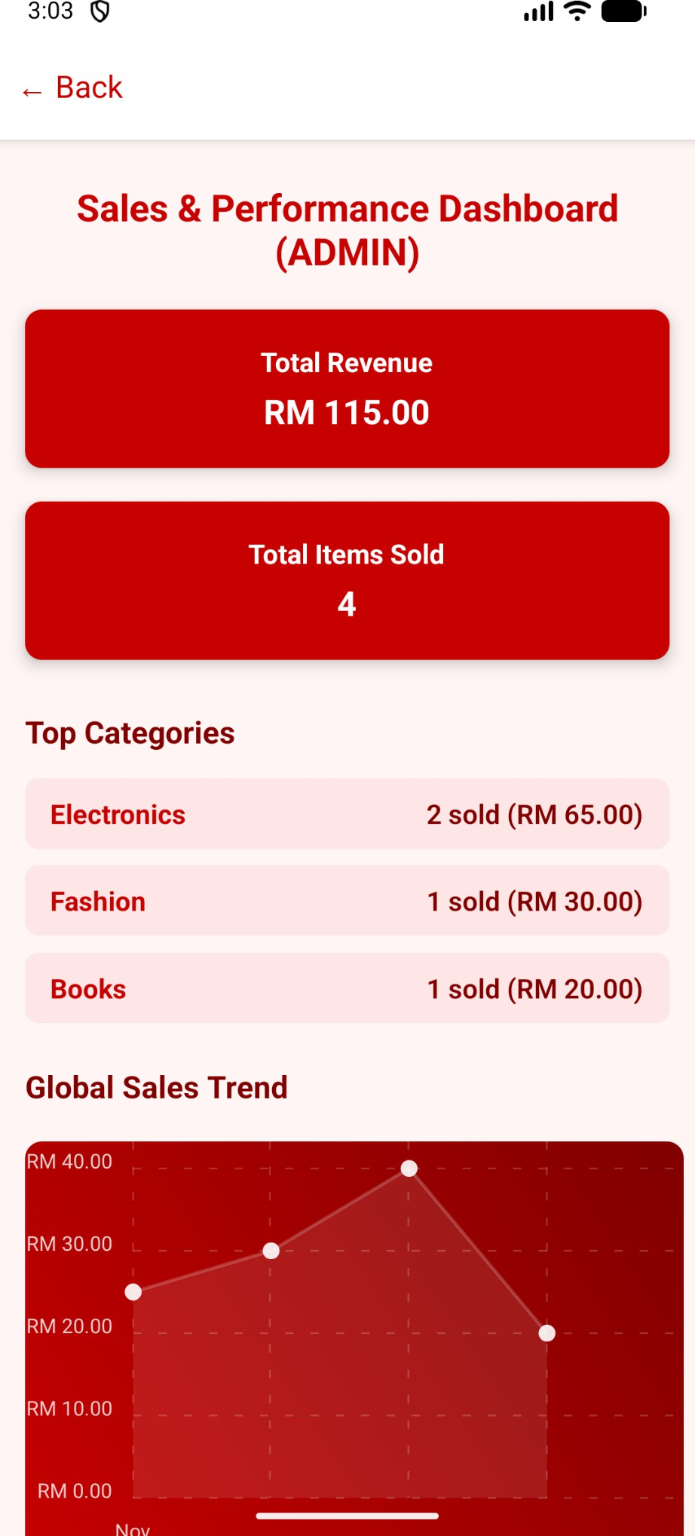
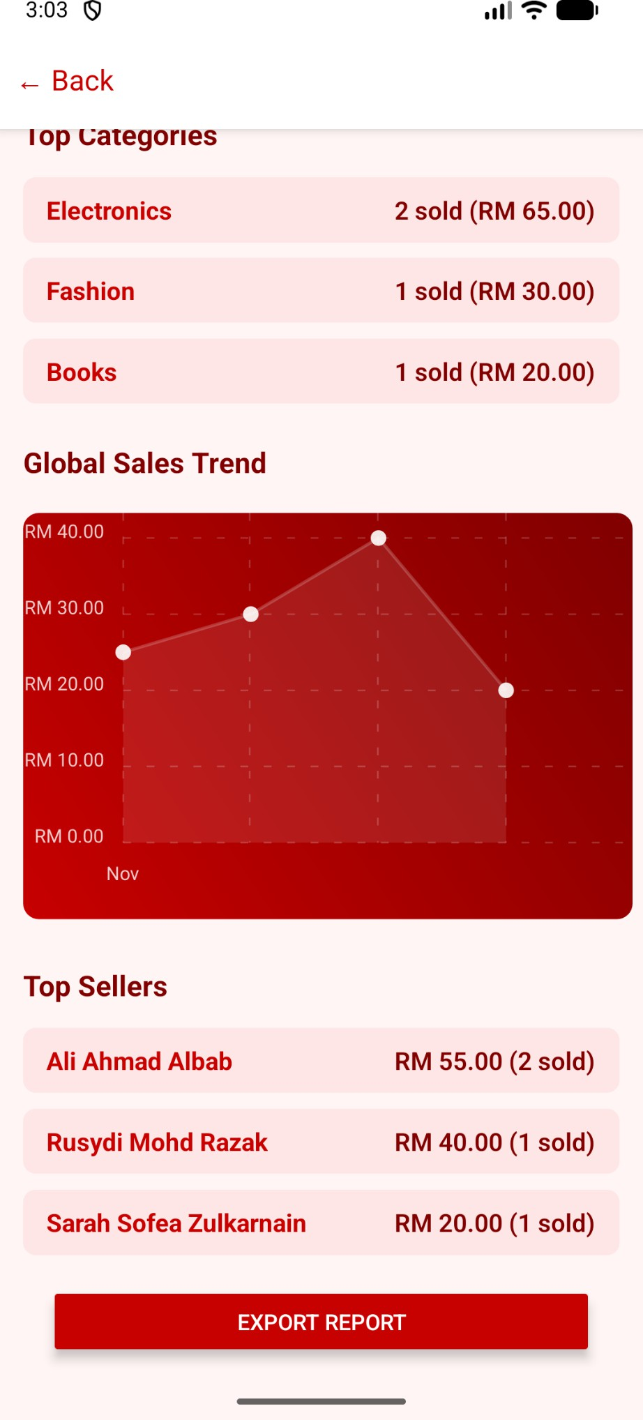
Figure 5.5 User Interface Design for Admin Sales and Performance Dashboard

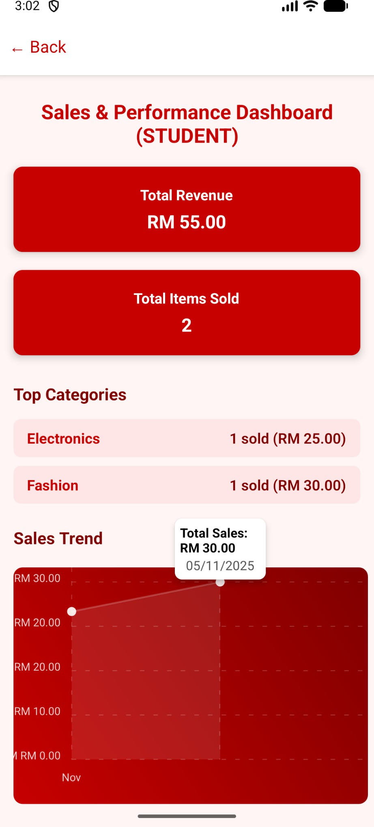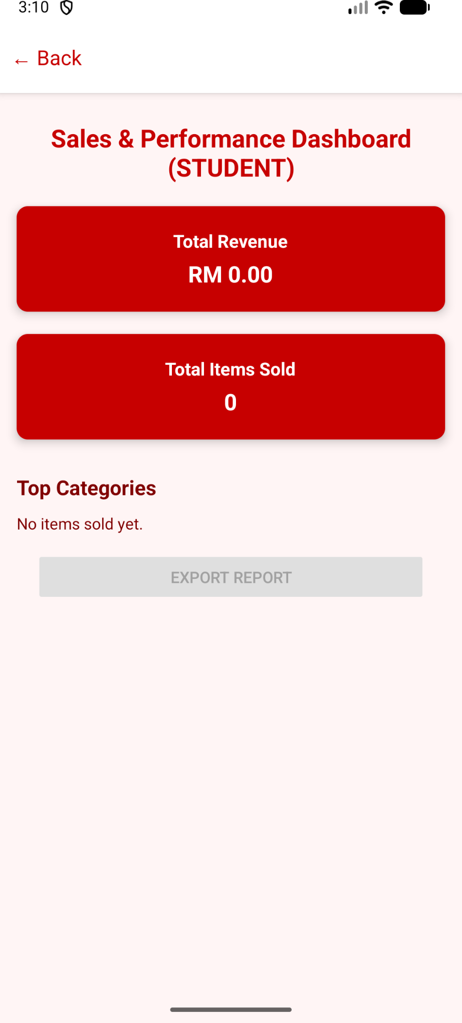
Figure 5.6 User Interface Design for Student Sales and Performance Dashboard

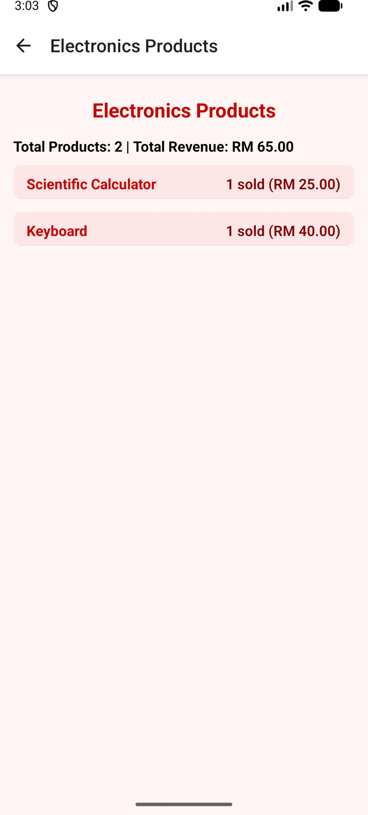
Figure 5.7 User Interface Design for Category Product Page

5.3 BUYER SPENDING SUMMARY MODULE (ASILAH)

5.3.1 DATA DESIGN

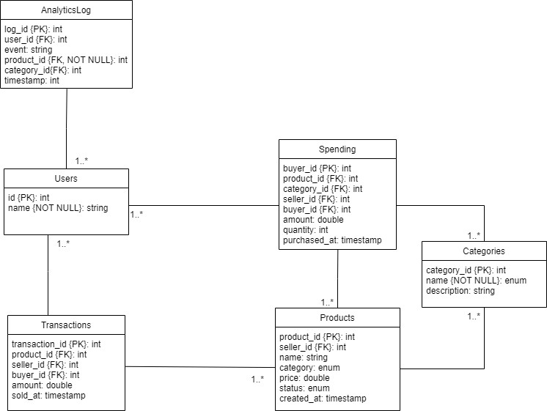
Figure 5.8: Entity Relationship Design (ERD) for Buyer Spending Summary Module

5.3.1.1 DATA DICTIONARY & DESCRIPTION

      - Users

Attribute Name | Data Type | Description
user_id | int | Unique identifier for each user
name | string | Name of the user
Table 5.11: Data Dictionary and Description of Users Table

      - Products

Attribute Name | Data Type | Description
product_id | int | Unique identifier for each product
seller_id | int | References the user who listed the product
name | string | Name of the product
category | string | Category of the product
price | double (decimal(10,2)) | Price of the product
status | string | Current status of the product
created_at | timestamp | Timestamp when the product was created/listed
Table 5.12: Data Dictionary and Description of Products Table

      - Transactions

Attribute Name | Data Type | Description
transaction_id | int | Unique identifier for each transaction
product_id | int | References the product sold
seller_id | int | References the seller of the product
buyer_id | int | References the buyer of the product
amount | double (decimal(10,2)) | Total amount for the transaction
sold_at | timestamp | Timestamp when the transaction occurred
Table 5.13: Data Dictionary and Description of Transactions Table

      - Spending

Attribute Name | Data Type | Description
buyer_id | int | References the buyer of the product
Product_id | int | References the product purchase
category_id | int | References the category of the product
seller_id | int | References the seller of the product
amount | double (decimal(10,2)) | Total amount for the transaction

quantity | int | Number of items purchased in this transaction
purchased_at | timestamp | Timestamp when the purchase occurred
Table 5.14: Data Dictionary and Description of Spending Table

      - Categories

Attribute Name | Data Type | Description
category_id | int | Unique identifier for each product category
name | string | Name of the category (e.g., Electronics, Books)
description | string | Brief description of the category
Table 5.15: Data Dictionary and Description of Categories Table

      - AnalyticsLogs

Attribute Name | Data Type | Description
log_id | int | Unique identifier for each analytics log entry
user_id | int | References the user who performed the action
event | string | Type of event performed by the user such as view, click, purchase
product_id | int | References the product involved in the event (if applicable)
category_id | int | References the category involved in the event (if applicable)
timestamp | datetime | Timestamp when the event occurred
Table 5.16: Data Dictionary and Description of AnalyticsLogs Table

5.3.2 USER INTERFACE DESIGN
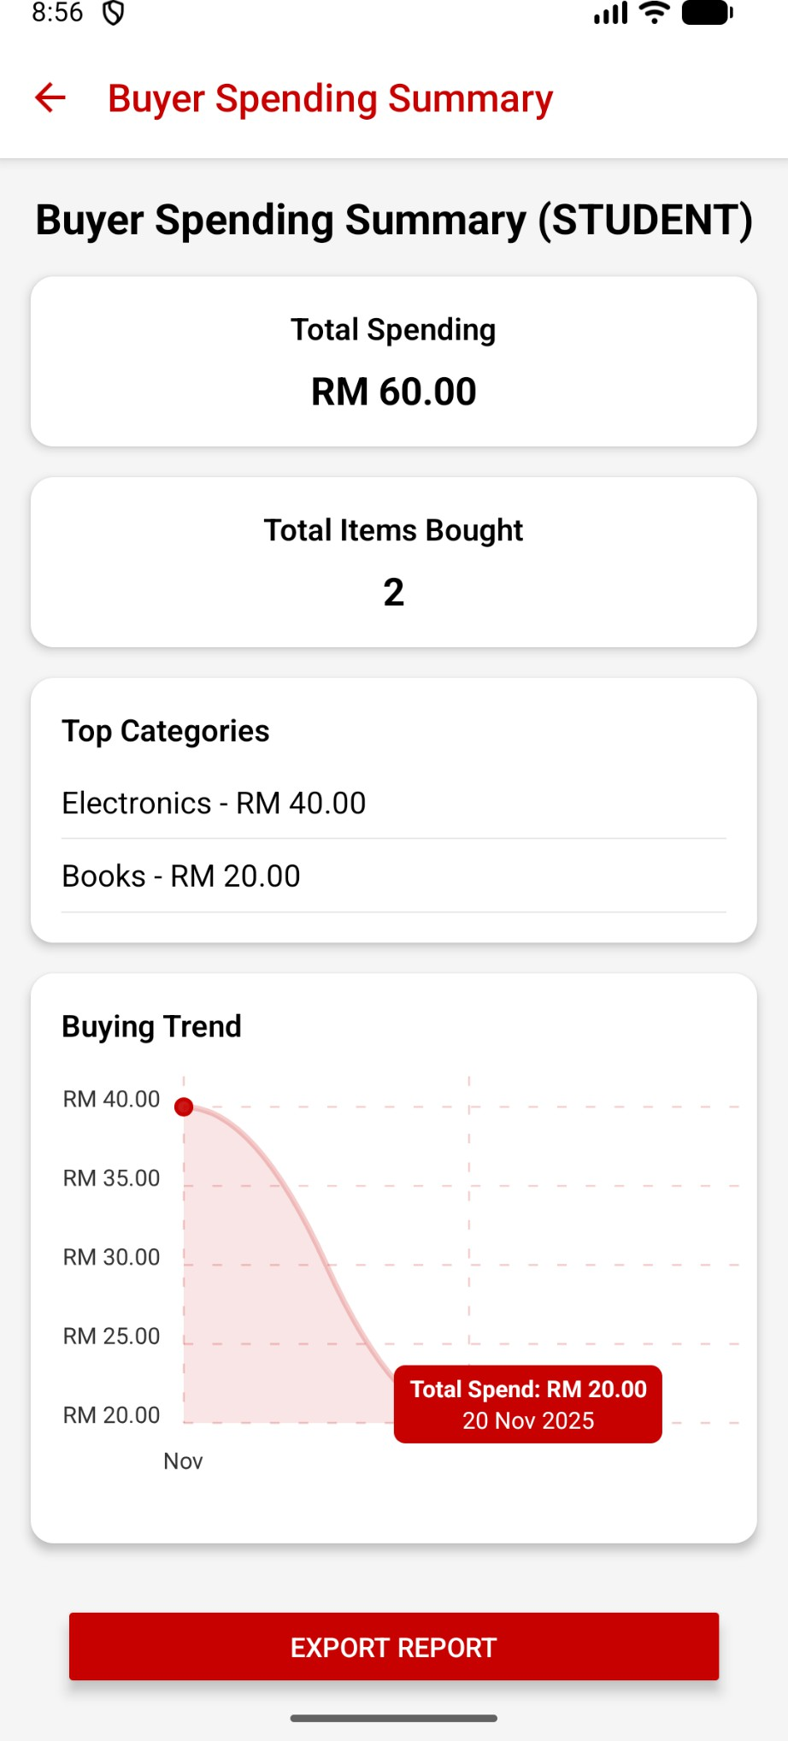
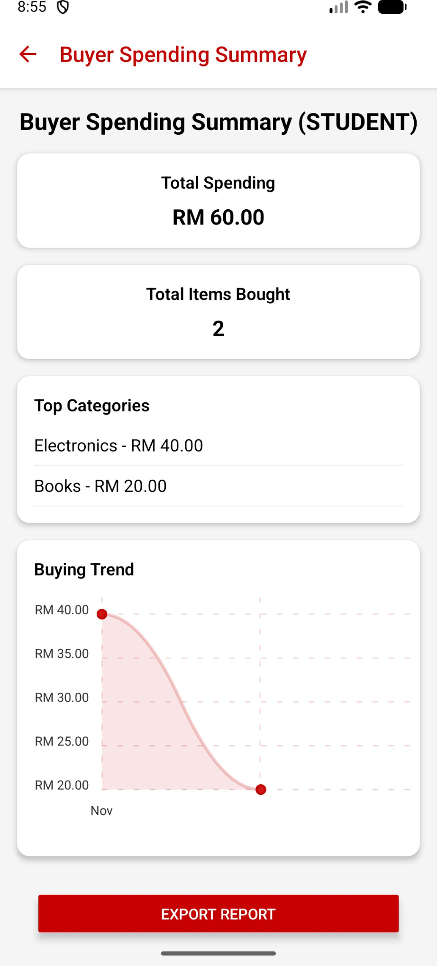

Figure 5.9 User Interface Design for Student Spending Summary Dashboard with interactive buying trend

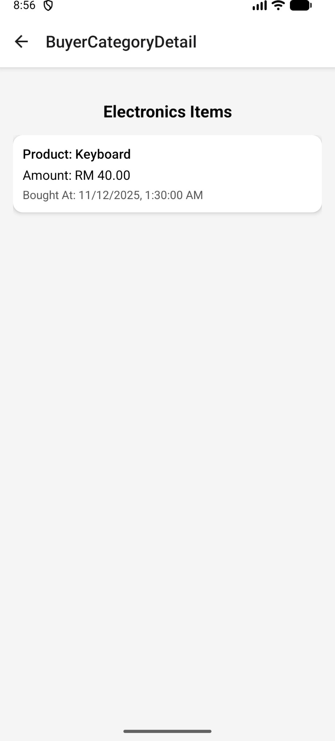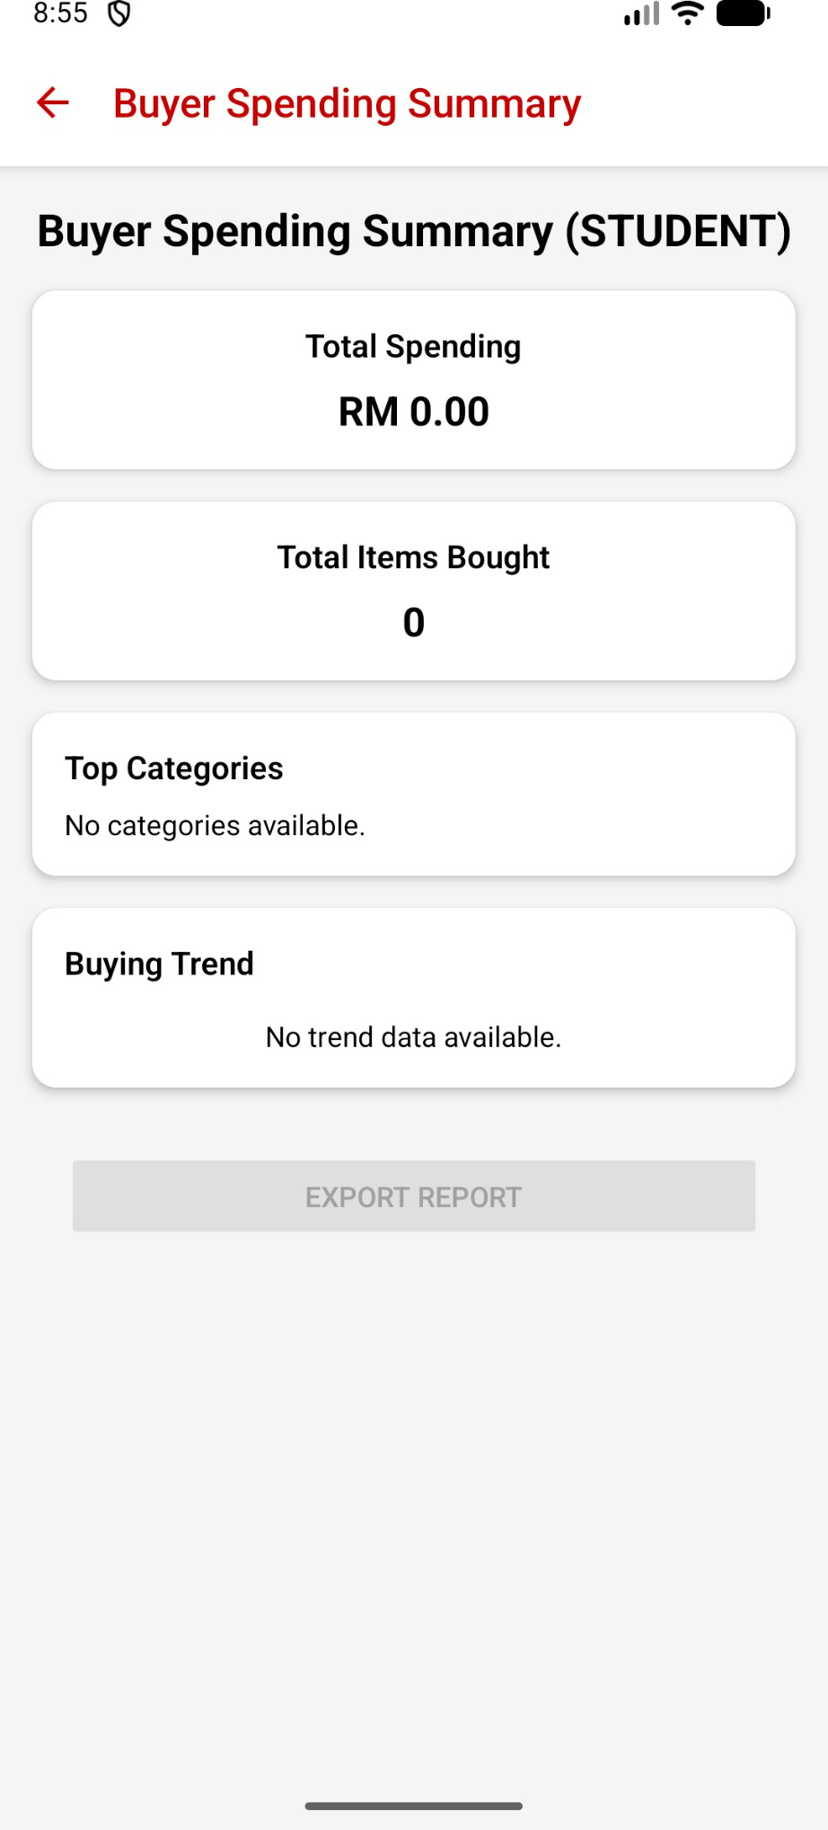
Figure 5.10 User Interface Design for Buyer Category Details page and No data available for Student Buying Summary Dashboard

6.0 COMMUNICATION AND SUPPORT SUBSYSTEM DATA DESIGN

6.1 CHAT & MESSAGING MODULE (JIA YING)

6.1.1 DATA DESIGN

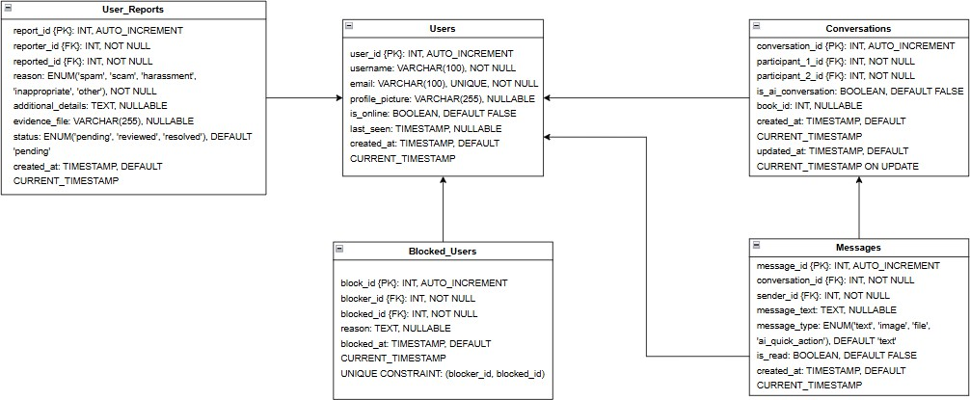

Figure 6.1 Entity Relationship Design (ERD) for Communication and support Module

6.1.1.1 DATA DICTIONARY & DESCRIPTION
Entity: User

Attribute name | Data Type | Constraints
user_id | INT | PRIMARY KEY, AUTO_INCREMENT
username | VARCHAR(100) | NOT NULL, Used for identification in chats
email | VARCHAR(100) | NOT NULL, UNIQUE, Used for  authentication
profile_picture | VARCHAR(255) | NULLABLE, Optional field
is_online | BOOLEAN | DEFAULT FALSE, Updated when user logs in/out
last_seen | TIMESTAMP | NULLABLE, NULL when user is online
created_at | TIMESTAMP | DEFAULT CURRENT_TIMESTAMP
Table 6.1: Data Dictionary and Description of User Table
Entity: Conversations

Attribute name | Data Type | Constraints
connversation_id | INT | PRIMARY KEY, AUTO_INCREMENT
participant_1_id | INT | NOT NULL, FOREIGN KEY →  users.user_id

participant_2_id | INT | NOT NULL, FOREIGN KEY →  users.user_id
is_ai_conversation | BOOLEAN | DEFAULT FALSE, TRUE if participant is AI
book_id | INT | NULLABLE, Links to books table (future)
created_at | TIMESTAMP | DEFAULT CURRENT_TIMESTAMP
updated_at | TIMESTAMP | DEFAULT CURRENT_TIMESTAMP, AUTO-UPDATE
Table 6.2: Data Dictionary and Description of Conversations Table

Entity: Messages

Attribute name | Type | Constrains
message_id | INT | PRIMARY KEY, AUTO_INCREMENT
conversation_id | INT | NOT NULL, FOREIGN KEY →  conversations.conversation_id
sender_id | INT | NOT NULL, FOREIGN KEY →  users.user_id
message_text | TEXT | NULLABLE, Empty if message_type is not text
message_type | ENUM | DEFAULT 'text', Options: text, image, file, ai_quick_action
is_read | BOOLEAN | DEFAULT FALSE, Set TRUE when  viewed
created_at | TIMESTAMP | DEFAULT CURRENT_TIMESTAMP
Table 6.3: Data Dictionary and Description of Messages Table

Entity: Blocked_Users

Attribute name | Type | Constrains
block_id | INT | PRIMARY KEY, AUTO_INCREMENT
blocker_id | INT | NOT NULL, FOREIGN KEY →  users.user_id
blocked_id | INT | NOT NULL, FOREIGN KEY →  users.user_id

reason | TEXT | NULLABLE, User's explanation
blocked_at | TIMESTAMP | DEFAULT CURRENT_TIMESTAMP
Table 6.4: Data Dictionary and Description of Blocked_Users Table

Entity: User_Reports

Attribute name | Type | Constrains
report_id | INT | PRIMARY KEY, AUTO_INCREMENT
reporter_id | INT | NOT NULL, FOREIGN KEY →  users.user_id
reported_id | INT | NOT NULL, FOREIGN KEY →  users.user_id
reason | ENUM | NOT NULL, Options: spam, scam, harassment, inappropriate, other
additional_details | TEXT | NULLABLE, Optional explanation
evidence_file | VARCHAR(255) | NULLABLE, Stored in uploads/ folder
status | ENUM | DEFAULT 'pending', Options: pending, reviewed, resolved
created_at | TIMESTAMP | DEFAULT CURRENT_TIMESTAMP
Table 6.5: Data Dictionary and Description of User_Reports Table

6.1.2 USER INTERFACE DESIGN
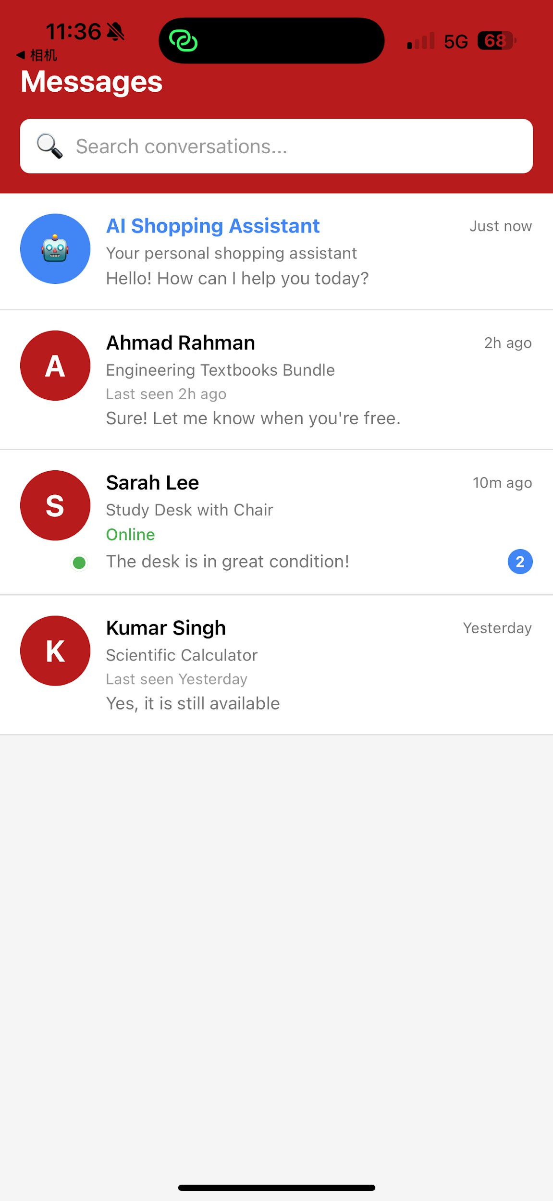

Figure 6.2: Main page for Communication and support Module

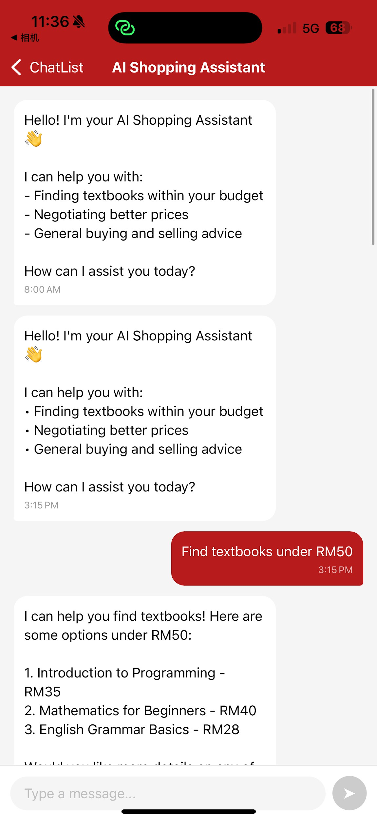
Figure 6.3: AI Assistant page for Communication and support Module

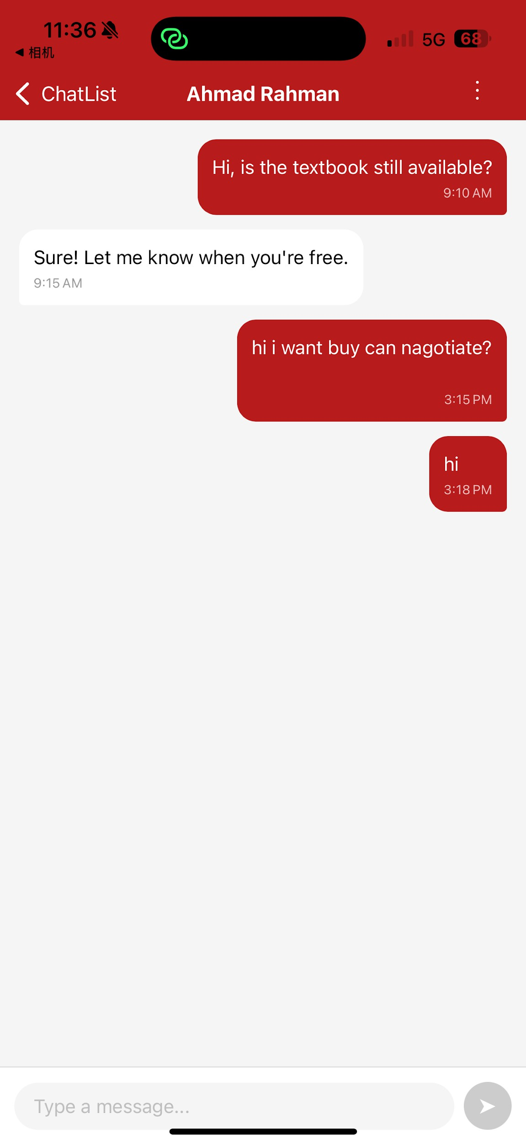
Figure 6.4: Chatbox with buyer or seller for Communication and support Module

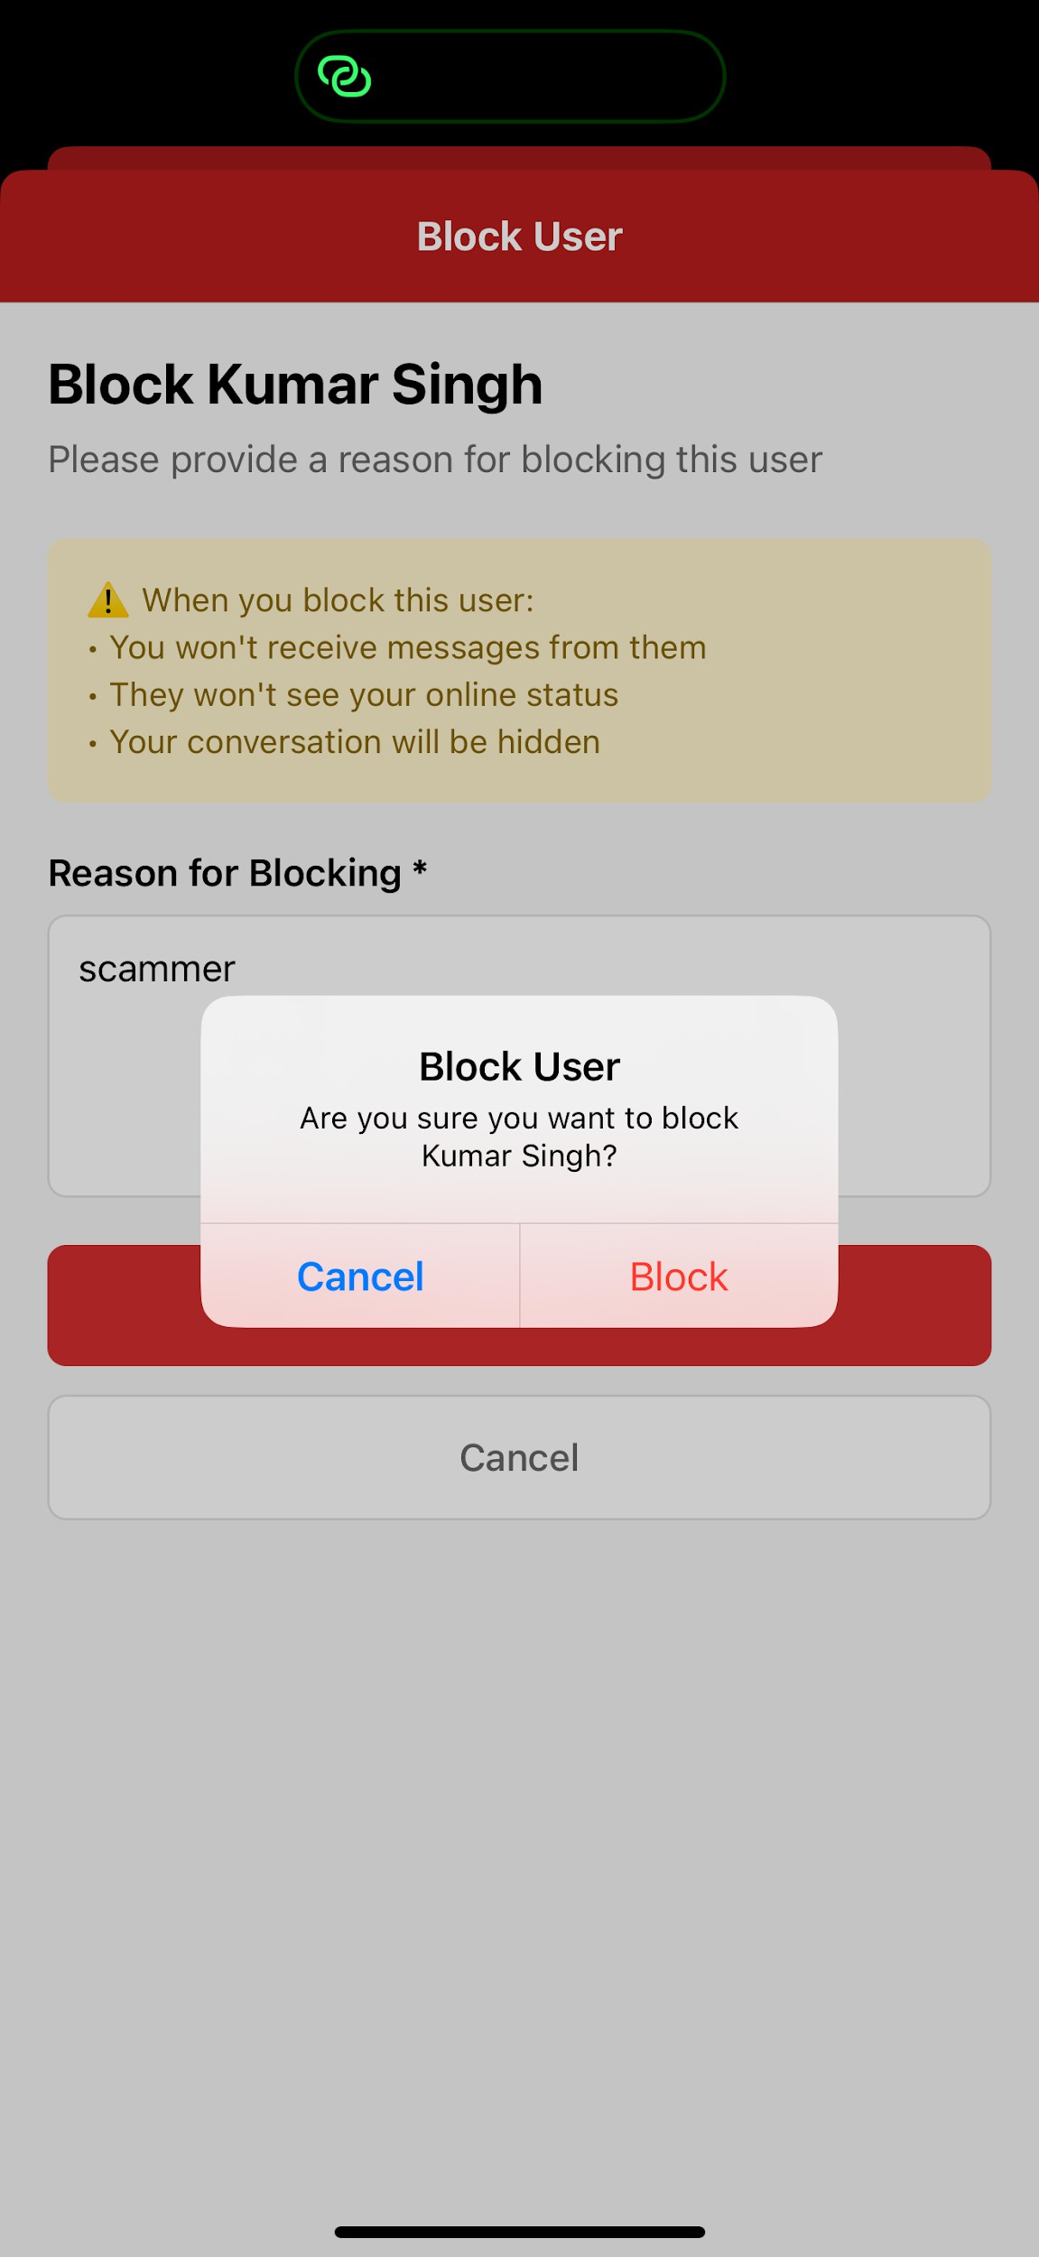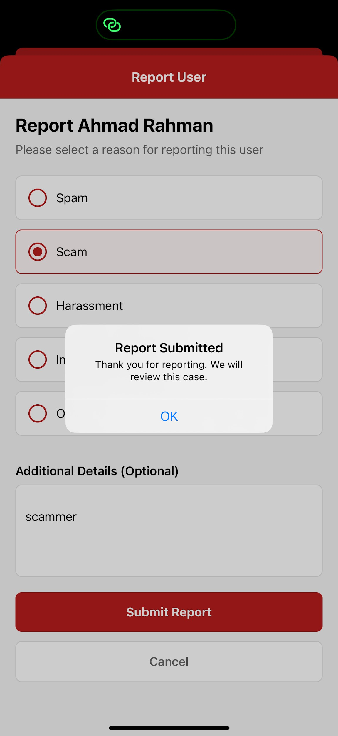
Figure 6.5: Report and Block user for Communication and support Module

6.2 NOTIFICATION & ALERT MODULE (JIA YING)

6.2.1 DATA DESIGN

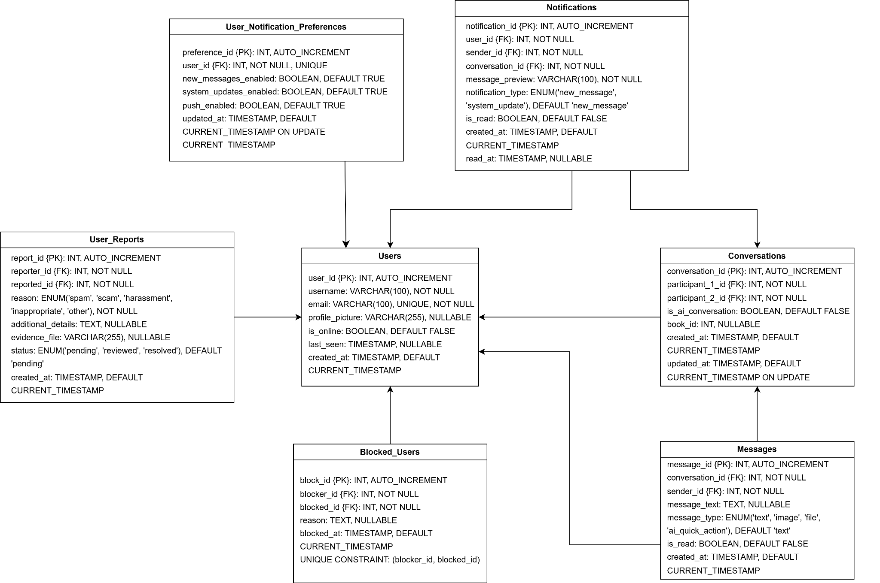
Figure 6.6: Entity Relationship Design (ERD) for Notification and Alert Module

6.2.1.1 DATA DICTIONARY & DESCRIPTION

Entity: Notifications

Attribute name | Data Type | Constraints
notification_id | INT | PRIMARY KEY, AUTO_INCREMENT
user_id | INT | NOT NULL, FOREIGN KEY →  users.user_id, Recipient of notification
sender_id | INT | NOT NULL, FOREIGN KEY →  users.user_id, Message sender
conversation_id | INT | NOT NULL, FOREIGN KEY →  conversations.conversation_id
message_preview | VARCHAR(100) | NOT NULL, Truncated preview text
notification_type | ENUM | DEFAULT 'new_message', Options: 'new_message', 'system_update'
is_read | BOOLEAN | DEFAULT FALSE, Updated when notification opened

created_at | TIMESTAMP | DEFAULT CURRENT_TIMESTAMP,  Sorted by this field
read_at | TIMESTAMP | NULLABLE, NULL until read
Table 6.7: Data Dictionary and Description of Notifications Table

Entity: User_Notification_Preferences

Attribute name | Data Type | Constraints
preference_id | INT | PRIMARY KEY, AUTO_INCREMENT
user_id | INT | NOT NULL, UNIQUE, FOREIGN KEY  → users.user_id
new_messages_enabled | BOOLEAN | DEFAULT TRUE, Controls notification creation
system_updates_enabled | BOOLEAN | DEFAULT TRUE, Reserved for future updates
push_enabled | BOOLEAN | DEFAULT TRUE, Controls push delivery method
updated_at | TIMESTAMP | DEFAULT CURRENT_TIMESTAMP, AUTO-UPDATE
Table 6.8: Data Dictionary and Description of User_Notification_Preferences Table

6.2.2 USER INTERFACE DESIGN
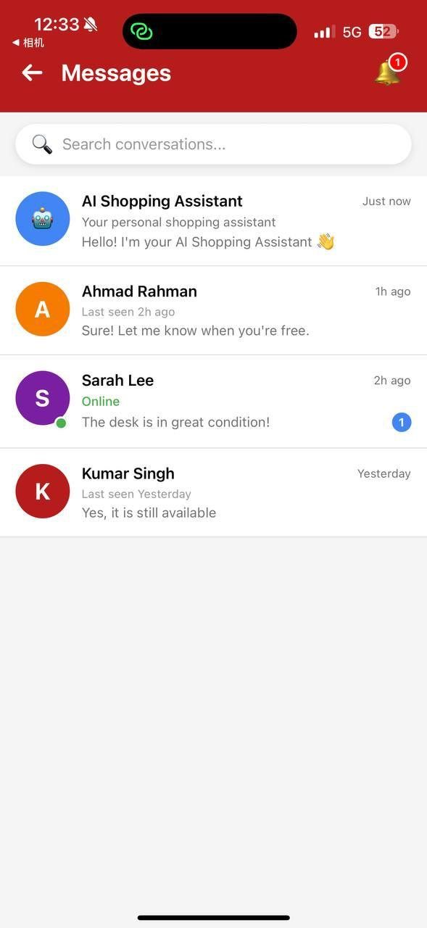
Figure 6.7: Main page for Notification and Alert Module

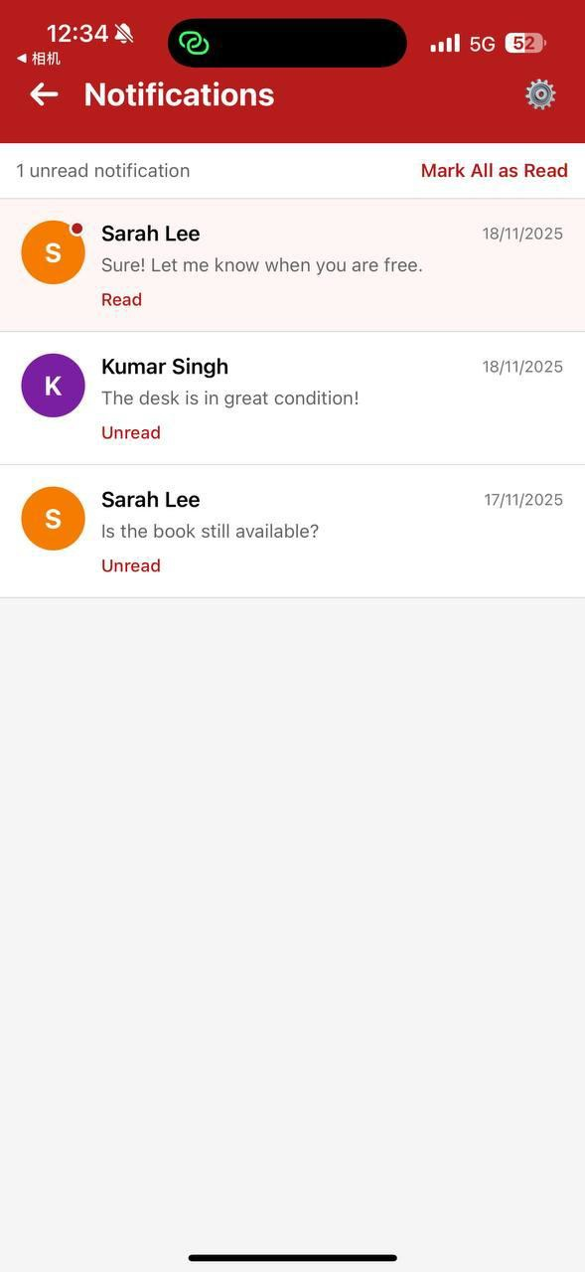
Figure 6.8: View Notification List for Notification and Alert Module

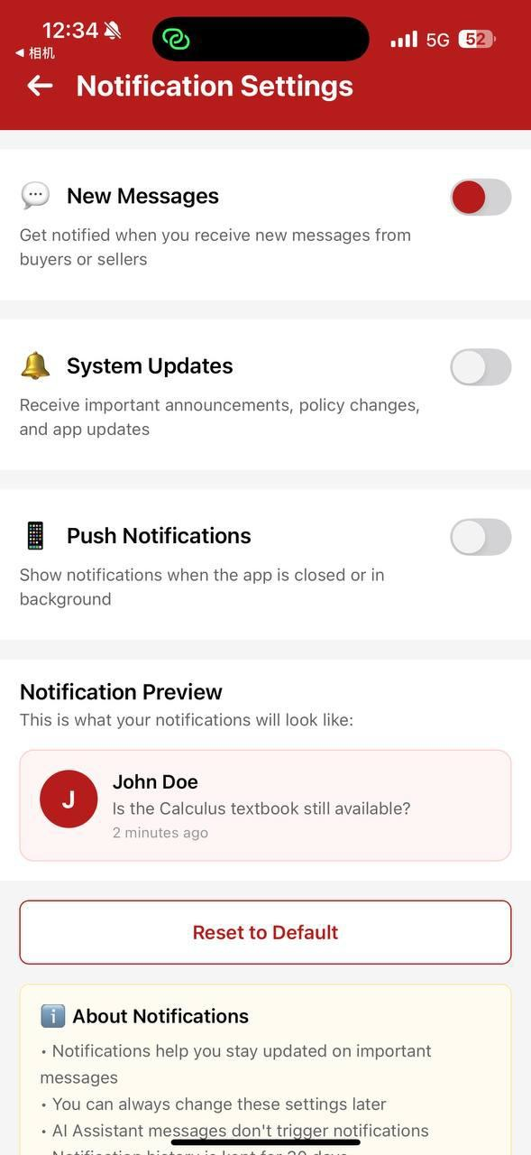
Figure 6.9: Notification Settings for Notification and Alert Module

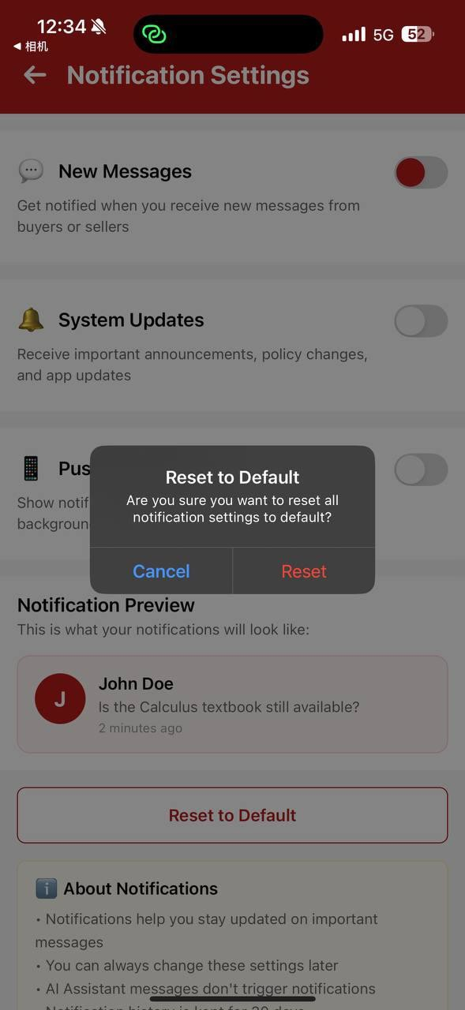
Figure 6.10: Reset to Default for Notification and Alert Module

6.3 HELP CENTRE AND FEEDBACK MODULE (JIA YING)

6.3.1 DATA DESIGN

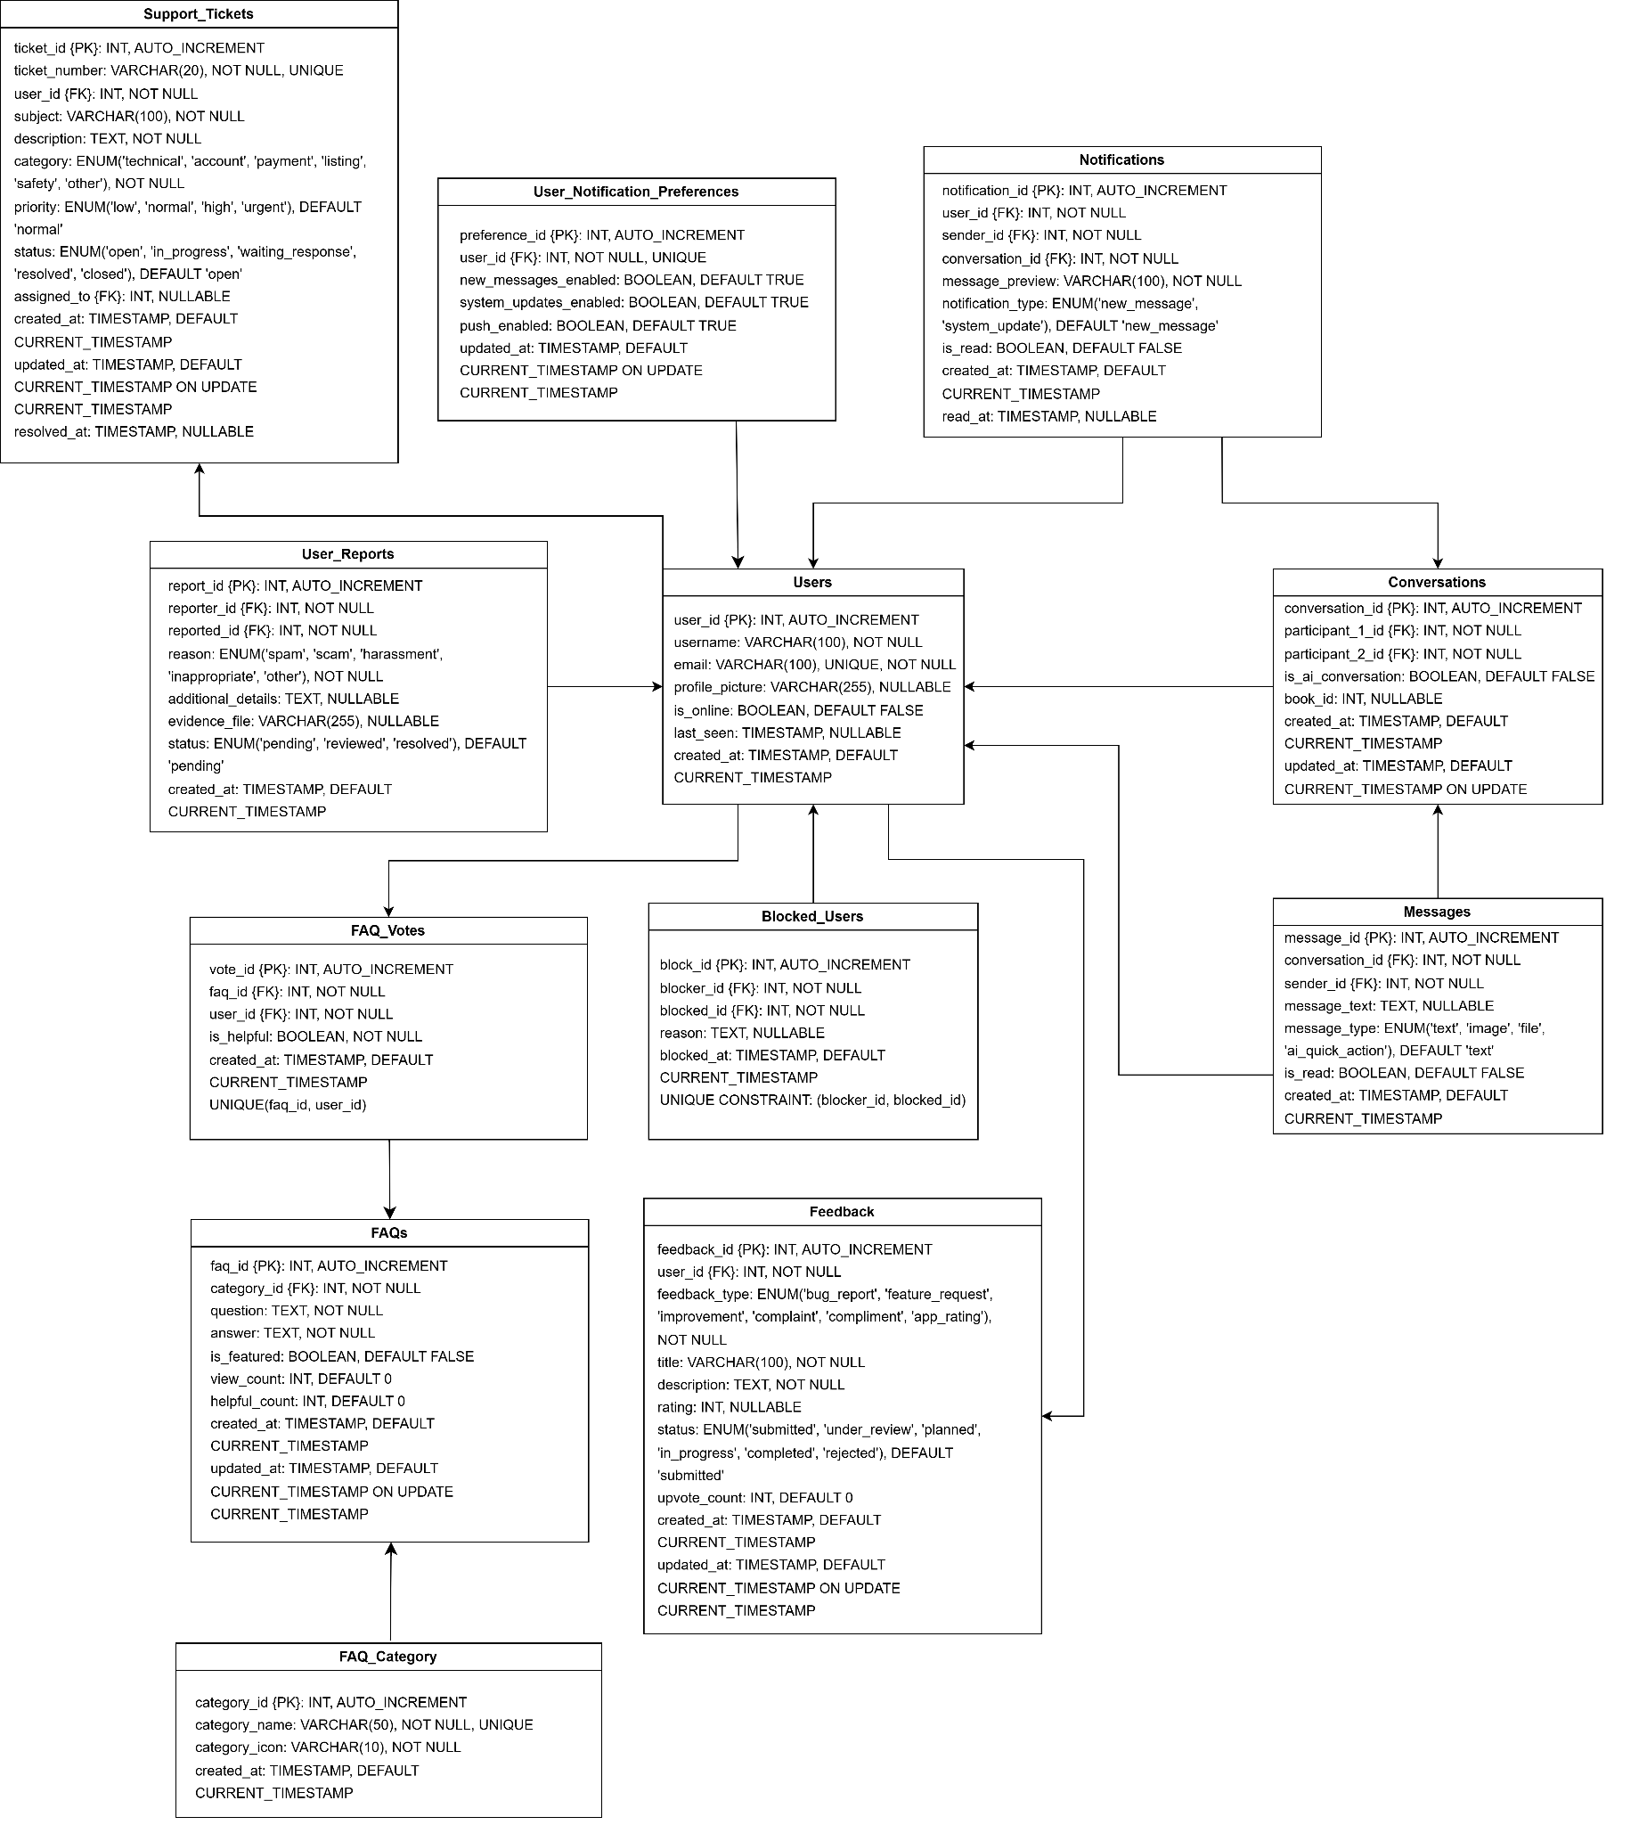
Figure 6.11: Entity Relationship Design (ERD) for Help center and Feedback Module

6.3.1.1 DATA DICTIONARY & DESCRIPTION
Entity: Feedback

Attribute name | Data Type | Constraints
feedback_id | INT | PRIMARY KEY, AUTO_INCREMENT
user_id | INT | NOT NULL, FOREIGN KEY →  users.user_id
feedback_type | ENUM | NOT NULL, Type of feedback
title | VARCHAR(100) | NOT NULL, Brief summary
description | TEXT | NOT NULL, Detailed feedback
rating | INT | NULLABLE, Range 1-5
status | ENUM | DEFAULT 'submitted'
upvote_count | INT | DEFAULT 0, Community upvotes
created_at | TIMESTAMP | DEFAULT CURRENT_TIMESTAMP
updated_at | TIMESTAMP | DEFAULT CURRENT_TIMESTAMP ON UPDATE CURRENT_TIMESTAMP
Table 6.9: Data Dictionary and Description of Feedback Table

Entity: FAQ_Categories

Attribute name | Data Type | Constraints
category_id | INT | PRIMARY KEY, AUTO_INCREMENT
category_name | VARCHAR(50) | NOT NULL, UNIQUE, Display name of category
category_icon | VARCHAR(10) | NOT NULL, Emoji icon for UI display
created_at | TIMESTAMP | DEFAULT CURRENT_TIMESTAMP
Table 6.10: Data Dictionary and Description of FAQ_Categories Table

Entity: FAQs

Attribute name | Data Type | Constraints
faq_id | INT | PRIMARY KEY, AUTO_INCREMENT
category_id | INT | NOT NULL, FOREIGN KEY →  faq_categories.category_id
question | TEXT | NOT NULL, The FAQ question

answer | TEXT | NOT NULL, The FAQ answer
is_featured | BOOLEAN | DEFAULT FALSE, Display in featured section
view_count | INT | DEFAULT 0, Number of views
helpful_count | INT | DEFAULT 0, Number of helpful votes
created_at | TIMESTAMP | DEFAULT CURRENT_TIMESTAMP
updated_at | TIMESTAMP | DEFAULT CURRENT_TIMESTAMP ON UPDATE CURRENT_TIMESTAMP
Table 6.11: Data Dictionary and Description of FAQs Table
Entity: FAQ_Votes

Attribute name | Data Type | Constraints
vote_id | INT | PRIMARY KEY, AUTO_INCREMENT
faq_id | INT | NOT NULL, FOREIGN KEY →  faqs.faq_id
user_id | INT | NOT NULL, FOREIGN KEY →  users.user_id
is_helpful | BOOLEAN | NOT NULL, TRUE = helpful, FALSE =  not helpful
created_at | TIMESTAMP | DEFAULT CURRENT_TIMESTAMP
 |  | UNIQUE(faq_id, user_id), Prevent duplicate votes
Table 6.12: Data Dictionary and Description of FAQ_Votes Table

Entity: Support_Tickets

Attribute name | Data Type | Constraints
ticket_id | INT | PRIMARY KEY, AUTO_INCREMENT
ticket_number | VARCHAR(20) | NOT NULL, UNIQUE, Format: TKT-YYYYMMDD-NNN
user_id | INT | NOT NULL, FOREIGN KEY →  users.user_id
subject | VARCHAR(100) | NOT NULL, Brief description
description | TEXT | NOT NULL, Detailed issue description
category | ENUM | NOT NULL

priority | ENUM | DEFAULT 'normal'
status | ENUM | DEFAULT 'open'
assigned_to | INT | NULLABLE, FOREIGN KEY →  users.user_id (admin)
created_at | TIMESTAMP | DEFAULT CURRENT_TIMESTAMP
updated_at | TIMESTAMP | DEFAULT CURRENT_TIMESTAMP ON UPDATE CURRENT_TIMESTAMP
resolved_at | TIMESTAMP | NULLABLE, Timestamp when resolved
Table 6.13: Data Dictionary and Description of FAQs Table

6.3.2 USER INTERFACE DESIGN
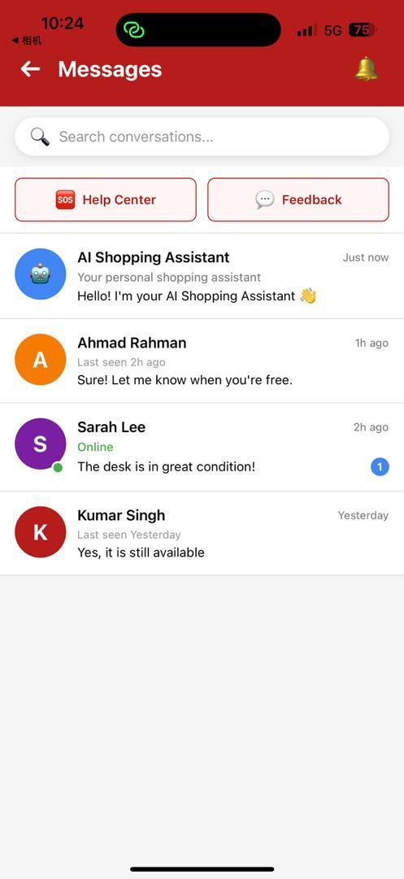
Figure 6.12: Main page for Help center and Feedback Module

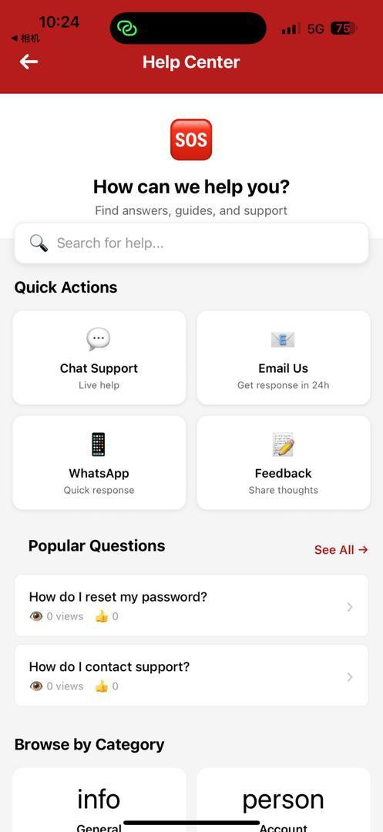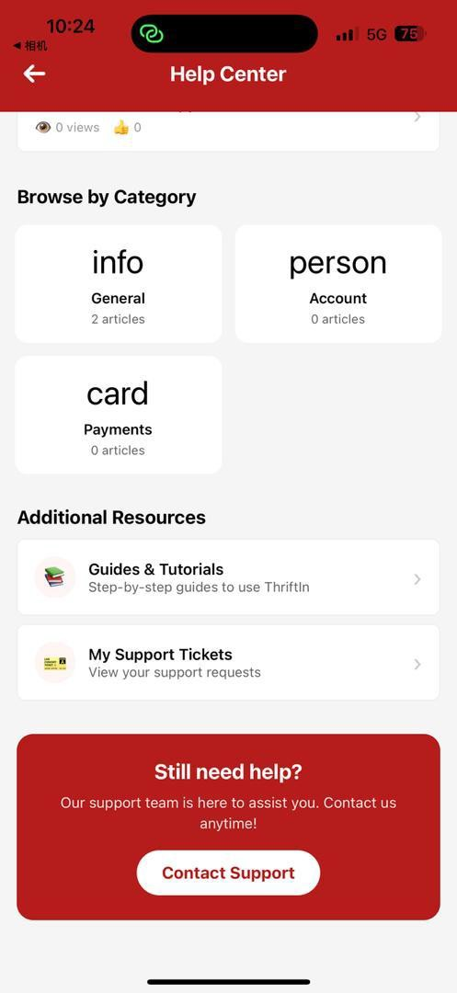
Figure 6.13: Help center for Help center and Feedback Module

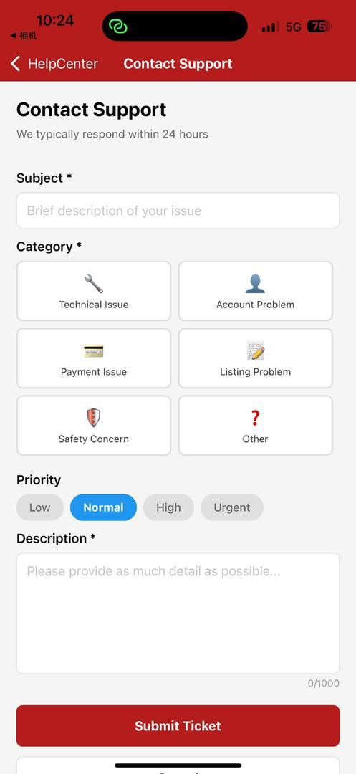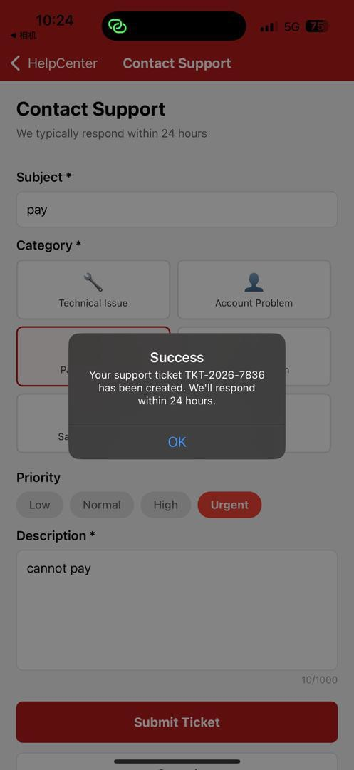
Figure 6.14: Contact Support for Help center and Feedback Module

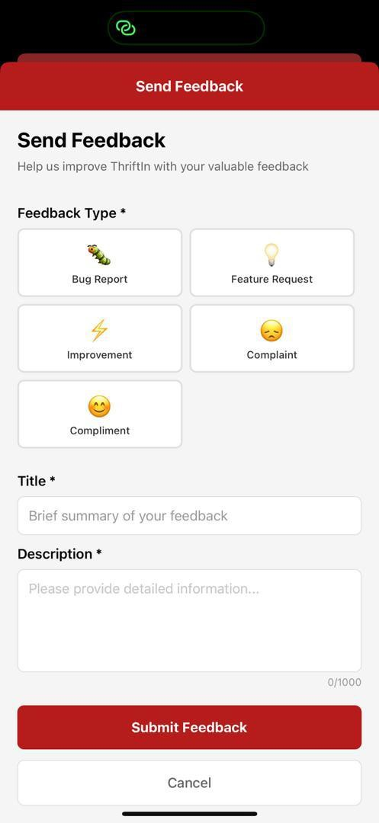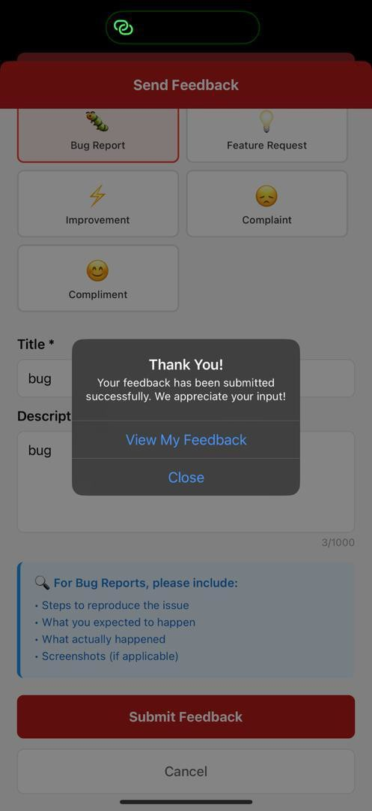
Figure 6.15: Feedback for Help center and Feedback Module

